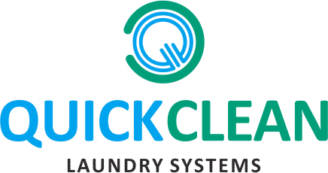

Operational Understanding of Healthcare Linen Rental Inventory Management System




GREAT LAKES INSTITUTE OF MANAGEMENT, GURGAON
Post Graduate Diploma in Management | PGDM 2025-27
SUMMER INTERNSHIP PROJECT REPORT
PROJECT TITLE
Operational Understanding of Healthcare Linen Rental Inventory Management System
SUBMITTED BY
Student Name: Krupa Raju
Roll Number: P2514037 | Batch / Section: PGDM 2025-2027
Specialisation / Domain: Operations
Email Address:  krupa.pgdm27g@greatlakes.edu.in | Contact Number:  +919633485045

COMPANY DETAILS  Company Name  Quick Clean Private Limited (Quick Clean Laundry Solutions)  Industry / Sector  On-Premise Laundry & Linen Management -Hospitality and Healthcare  Location  Gurugram, Haryana  Company Guide Name & Designation  Mr. G Dhivakar  Vice President- Operations | FACULTY MENTOR  Faculty Mentor Name  Dr. Ravindra Ojha  Designation  Faculty Guide  Department  Great Lakes Institute of Management, Gurgaon  Date of Submission  23rd June 2026
Submitted in partial fulfilment of the requirements of the Post Graduate Diploma in Management
Great Lakes Institute of Management, Gurgaon

ACKNOWLEDGEMENT

The completion of this Summer Internship Project has been one of the most enriching learning experiences of my management journey, and it would not have been possible without the guidance, patience and trust extended to me by a number of people.

I express my deepest gratitude to my company guide, Mr. Dhivakar Gopal, Head of Operations at Quick Clean Laundry Systems, who entrusted me with a genuinely unexplored a grey area within the organisation’s healthcare operations, and gave me the freedom to investigate it end-to-end. His clarity of thought, his insistence on evidence over assumption, and his willingness to let an intern challenge an established process shaped both this project and the way I now approach operational problems.

I am sincerely thankful to Mr. C.D. Sharma (Operations Lead in Healthcare) for validating my analytical approach and connecting me with the right people across sites; to Mr. Aman Singh (Purchase & Administration) for cross-verifying procurement records against my analysis; and to Ms. Antima from the Finance team, whose early endorsement of my methodology gave me the confidence to scale the analysis. My thanks also go to Mr. Shivaji and the entire laundry team at Lilavati Hospital & Research Centre, Mumbai, who patiently walked me through every stage of the laundry floor during the physical audit and answered my unending questions. I remain grateful to Mr. Anshul Gupta, Founder, for building an organisation where an intern’s recommendations are taken seriously.

I extend my heartfelt thanks to my faculty mentor, Prof. Ravindra Ojha, for his constant academic guidance, the structure he brought to my project, and his sharp, constructive feedback that consistently pushed the quality of this work higher. In addition, I am incredibly grateful to the Great Lakes Institute of Management, Gurgaon for giving me the training I needed and the chance to work as an intern. Being a part of an organization that prioritizes professional growth and academic rigor makes me proud.
Finally, I would like to acknowledge everyone who supported me throughout this journey, directly or indirectly, and enabled me to contribute meaningfully to both the organization and my academic goals.

CERTIFICATE OF ORIGINALITY AND AUTHENTICITY

I, Krupa Raju (Roll No. P2514037), a student of the Post Graduate Diploma in Management (Batch 2025-27) at Great Lakes Institute of Management, Gurgaon, hereby declare that this Summer Internship Project report titled “Operational Understanding of Healthcare Linen Rental Inventory Management System” is an original piece of work carried out by me during my internship at Quick Clean Laundry Systems.
I further declare that the physical stock audit, the analysis, the findings, the templates, the dashboards and the recommendations presented in this report are the result of my own effort and observation at the project site, and have not been copied or reproduced from any other source except where explicitly cited.
All data, figures and tables used in this report have been drawn from records made available to me by Quick Clean Laundry Systems for academic purposes, or generated by me through primary observation and analysis. This report has not been submitted, in whole or in part, for the award of any other degree, diploma or qualification at this or any other institution.
Wherever the work of others has been referred to, due acknowledgement has been made and the sources have been listed in the bibliography.

Krupa Raju
Roll No. P2514037
PGDM-2025 - 2027

CERTIFICATE OF COMPLETION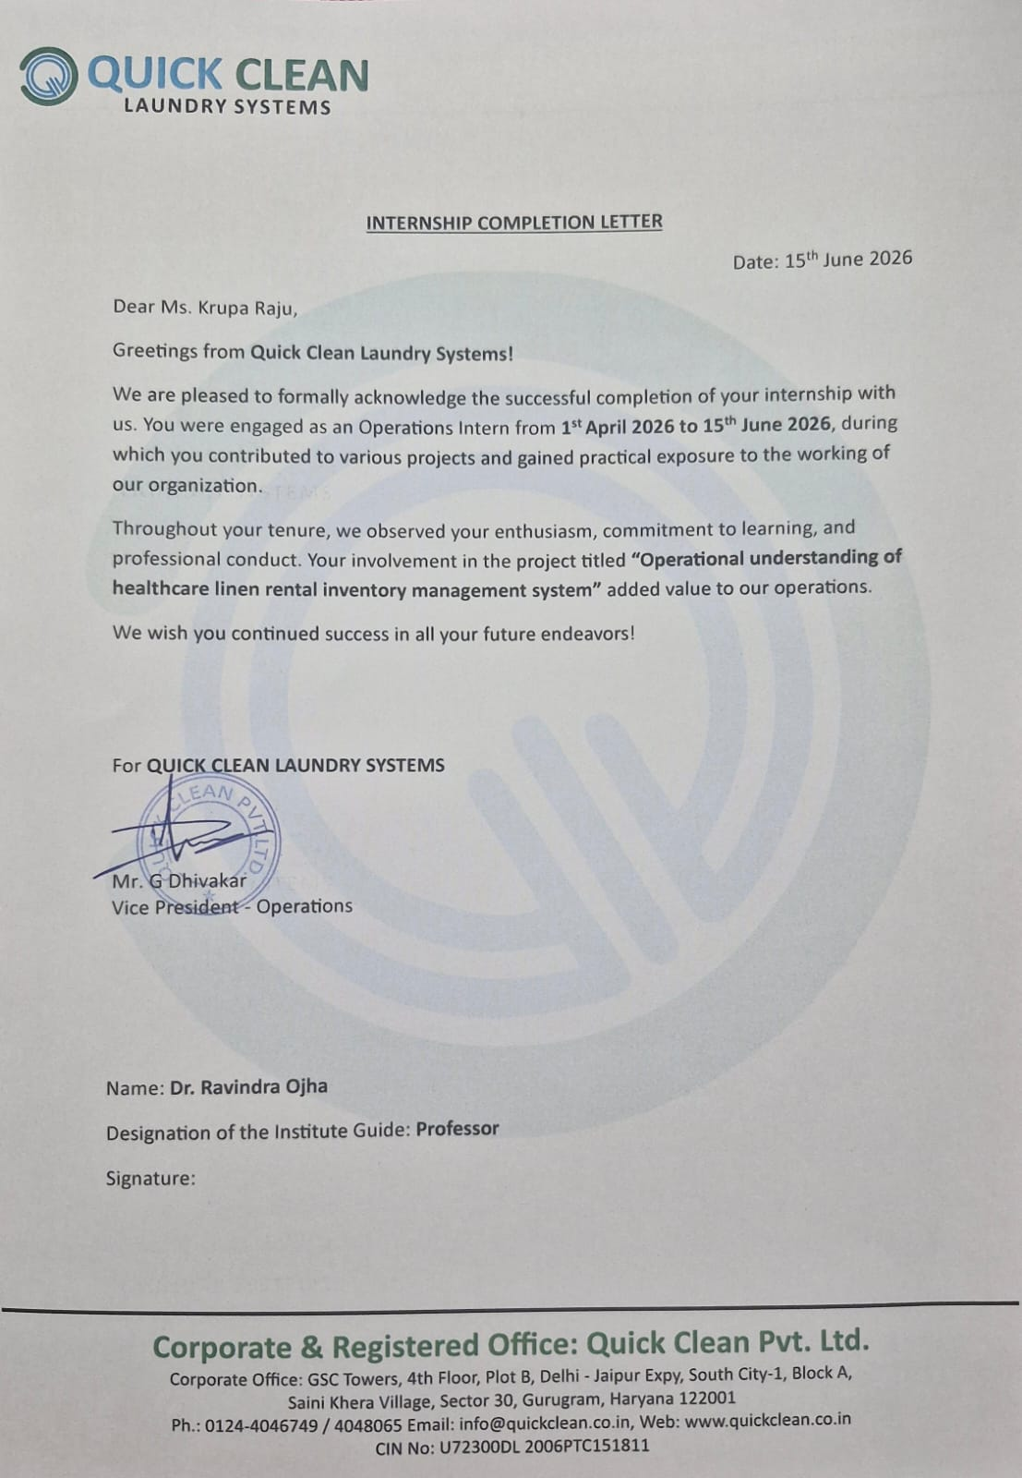

TABLE OF CONTENTS

ACKNOWLEDGEMENT 3
CERTIFICATE OF ORIGINALITY AND AUTHENTICITY 4
CERTIFICATE OF COMPLETION 5
LIST OF TABLES 10
LIST OF FIGURES 12
LIST OF ABBREVIATIONS 13
EXECUTIVE SUMMARY 14
ONE PAGER SUMMARY OF THE PROJECT 15
CHAPTER 1: ORGANISATION & INDUSTRY OVERVIEW 16
1.1 About Quick Clean Laundry Systems 17
1.2 The Indian Healthcare Linen and On-Premise Laundry Industry 17
1.3 Details of the Company 18
1.4 Definition of "Great Place to Work" 18
1.5 Organizational Ethos and Work Culture 19
1.6 Company Culture & Structure 19
1.7 Business Model 20
1.8 SWOT Analysis 21
1.9 Industry Analysis: Porter's Five Forces 22
1.10 Model of Operations: Inputs, Process and Outputs 24
1.11 Title of the Project 25
1.12 Need for the Study 25
1.13 Objectives of the Study 26
1.14 Scope of the Study 26
1.15 Research Methodology 26
1.16 Deriving the 1-PAR and 3-PAR Baseline 28
1.17 Cost-Impact Analysis Methodology 29
1.18 Discard and Trend Analysis Methodology 30
1.19 Missing-Linen and Procurement (Requirement) Methodology 30
1.20 Tools and Technologies Used 31
1.21 Limitations of the Study 32

CHAPTER 2: LITERATURE REVIEW 33
2.1 Introduction and Research Context 34

2.2 Healthcare Linen Services: Scope and Key Concepts 34
2.3 Linen Management Protocols and Standard Operating Procedures 34
2.4 Inventory Variance in Healthcare Linen: Empirical Evidence 35
2.5 Infection Control as a Driver of Linen Standards 35
2.6 The Rental / BOO Lifecycle and the Visibility Problem 35
2.7 PAR-Level Theory: The Heart of Linen Inventory Control 36
2.8 Technology in Linen Tracking: Barcode and RFID 36
2.9 Accreditation and Quality Standards 37
2.10 Key Operational Metrics and Benchmarks 37
2.11 Research Gap and Implications for the Project 37
2.12 Literature vs. Practice: A Comparative Synthesis 38

CHAPTER 3: LINEN LIFECYCLE MAPPING & GAP IDENTIFICATION 40
3.1 The Pilot Site: Lilavati Hospital & Research Centre 41
3.2 Mapping the Linen Lifecycle 41
3.3 The 1-PAR Baseline: Deriving the Demand Anchor 41
3.4 Gaps Identified During the Audit 43

CHAPTER 4: INVENTORY ANALYSIS & QUANTIFIED FINDINGS 46
4.1 The Eight-Analysis Framework 47
4.2 White Linen Analysis 47
4.3 Green Linen Analysis 50
4.4 Synthesis of Findings 55

CHAPTER 5: DESIGNING THE TRACKING & REPORTING SYSTEM 56
5.1 Design Philosophy 57
5.2 Component 1: The Standardised Linen-Management Toolkit 57
5.3 Component 2: The Quick Clean Discard Management Platform 58
5.4 Component 3: The Centralised Inventory-Tracking Dashboard 61
5.5 Component 4: A Phased Linen-Tagging Roadmap 63
5.6 How the Four Components Work Together 63

CHAPTER 6: RECOMMENDATIONS 64
6.1 A Phased Recommendation Roadmap 65
6.2 International Best Practices Worth Adopting 66

6.3 A KPI Framework for Ongoing Control 67

CHAPTER 7: CONCLUSION, LEARNINGS & SCOPE FOR FUTURE WORK 68
7.1 Conclusion 69
7.2 Key Learnings from the Internship 69
7.3 Scope for Future Work 70

BIBLIOGRAPHY & REFERENCES 73

LIST OF TABLES

Table | Title
Table 1 | Key Facts - Quick Clean Laundry Solutions (Quick Clean Private Limited)
Table 2 | The three project objectives and their treatment in this report
Table 3 | The six primary data sources collected and audited during the project
Table 4 | Tools and technologies used to conduct the project, and the technology stack specified for the proposed system
Table 5 | Literature themes compared against findings and current practice at Lilavati, with items that could not be directly benchmarked recorded as challenges for future work
Table 6 | 1-PAR (average daily floor-issue) and 3-PAR target by item, White and VIP linen, Lilavati Hospital - the baseline used throughout this audit (figures rounded to the nearest whole unit)
Table 7 | Legacy April bed-wise PAR estimate, Lilavati Hospital superseded by the average-issue baseline in Table 5 above and shown here only for comparison (VIP wing: 56 beds → 224 bed sheets, 112 draw sheets, 224 pillow covers, 224 towels, 168 blankets)
Table 8 | The eight analyses and the decision each one supports
Table 9 | White-linen 3-PAR position, Lilavati Hospital (18 May 2026)
Table 10 | VIP-linen 3-PAR position. Note: against the April bed-wise estimate (3-PAR of 474–768 per item) every VIP category is deeply short the May floor-issue 3-PAR shown here is far lower, itself evidence of suppressed issue counts
Table 11 | Green / OT-linen 3-PAR position: selected high-impact items (18 May 2026)
Table 12 | Missing-linen value summary. Against the literature’s 2–5% acceptable annual loss benchmark, a single-month gap of this scale at one site is materially above norm
Table 13 | Procurement plan summary: only genuine 3-PAR shortfalls are bought, preventing over-indenting
Table 14 | Discard-rate categorisation and representative items
Table 15 | The six modules of the standardised linen-management toolkit and the specific gap each one closes
Table 16 | The phased linen-tagging roadmap: stamping, then barcode, then RFID- each phase funding the case for the next
Table 17 | The phased recommendation roadmap, each action mapped to the specific gap or finding it resolves
Table 18 | Recommended monthly KPI framework, tracked site-wise through the centralised dashboard

LIST OF FIGURES

Table | Title
Figure 1 | Quick Clean -Great Place to Work Structure
Figure 2 | Quick Clean - Functional Structure (as Encountered During Internship)
Figure 3 | Quick Clean BOO Business Model -Process Flow
Figure 4 | Quick Clean SWOT Analysis
Figure 5 | Porter's Five Forces - Organised OPL Industry
Figure 6 | The Quick Clean On-Premise Laundry (OPL) process flow observed at Lilavati Hospital
Figure 7 | The audit reconciliation logic: Expected Closing Stock vs Observed Total → Variance
Figure 8 | Methodology for deriving the 1-PAR and 3-PAR baseline from average daily floor-issue, and classifying the resulting gap as shortage or excess
Figure 9 | Methodology for the cost-impact analysis: pricing shortage and missing linen into a monthly and an annualised rupee exposure
Figure 10 | Methodology for the discard and trend analysis: four months of discard logs reduced to a daily average discard rate and a High/Moderate/Low severity band
Figure 11 | Methodology for the missing-linen value and procurement (requirement) analysis: variance drives both the severity ranking and the replenishment quantity
Figure 12 | The closed-loop healthcare linen lifecycle under the rental / BOO model
Figure 13 | Evidence of data loss: the current item-only discard template (left) versus the proposed size-bifurcated standard template (right)
Figure 14 | White line: variance against the 3-PAR target by item (negative = shortage)
Figure 15 | Green / OT linen: variance against the 3-PAR target for selected items
Figure 16 | Highest-value missing-linen items across both streams (May 2026)
Figure 17 | Annualised cost of missing linen by stream (single-site, May 2026 basis)
Figure 18 | Month-on-month discard trend (Feb-May 2026) for the highest-attrition items
Figure 19 | Accuracy of April PAR estimates versus the actual May 3-PAR, by stream
Figure 20 | The standardized template that is been delivered to quick clean after analysis
Figure 21 | The digital discard-approval workflow implemented in the Quick Clean Discard Management platform -from evidence capture at the floor to finance-ready write-off
Figure 22 | The three-tier architecture of the discard-management platform
Figure 23 | The Quick Clean Discard work flow dashboard which is being delivered
Figure 24 | The QCPL-Centralised Inventory-Tracking Dashboard which is being delivered

LIST OF ABBREVIATIONS

Abbreviation | Full Form
PAR | Periodic Automatic Replenishment (par-stock level)
OPL | On-Premise Laundry
BOO | Build-Own-Operate
OT | Operating Theatre
CSSD | Central Sterile Services Department
OPD | Out-Patient Department
RMO | Resident Medical Officer
LM | Linen Manager
RM | Regional Manager
HO | Head Office
P&A | Purchase & Administration
KPI | Key Performance Indicator
RFID | Radio-Frequency Identification
SOP | Standard Operating Procedure
NABH | National Accreditation Board for Hospitals & Healthcare Providers
NHSRC | National Health Systems Resource Centre
HLAC | Healthcare Laundry Accreditation Council
TRSA | Textile Rental Services Association
VIP | Very Important Person (premium wing)
SIP | Summer Internship Project

EXECUTIVE SUMMARY

This Summer Internship Project was undertaken with Quick Clean Private Limited, a leading provider of healthcare and hospitality linen rental and laundry services, to develop an operational understanding of linen inventory management under the company’s Build-Own-Operate (BOO) model and to design a structured system for its effective management. Healthcare linen plays a critical role in ensuring patient comfort, infection control, and the seamless functioning of hospital operations. Effective linen management requires accurate monitoring of inventory throughout its lifecycle, including procurement, usage, laundering, redistribution, and discard. However, the absence of a comprehensive inventory tracking mechanism often results in inventory inaccuracies, stock shortages, excess procurement, and operational inefficiencies.
The project, titled “Operational Understanding and Initiation of a Healthcare Linen Inventory Management System,” focused on understanding existing linen management practices, mapping the linen lifecycle, identifying gaps in inventory visibility, and developing a framework for effective inventory tracking and control under the linen rental model. At the outset, healthcare linen inventory tracking was identified as a significant operational challenge for the organization, as there was no single, reliable, item-wise view of linen available at a site, linen in circulation, or linen lost during operations. Since the linen is owned by Quick Clean under the rental model, every untracked item directly impacts the company’s costs and profitability.
Given the operational constraints of physically auditing all healthcare sites within the internship duration, “Lilavati Hospital & Research Centre, Mumbai”, a large multi-speciality healthcare facility operating both White Linen (ward) and Green Linen (OT/CSSD) streams, was selected as a representative pilot site. The study involved reviewing stock records, validating inventory data through audit reports, and conducting PAR-based requirement analysis to assess stock adequacy and inventory accuracy. Particular emphasis was placed on understanding linen movement across different stages of the lifecycle and evaluating the effectiveness of existing inventory management practices.
The analysis revealed that while White Linen inventory was largely traceable through available records, significant challenges existed in tracking Green Linen used in Operation Theatres, CSSD, and Cath Labs due to the absence of department-level consumption tracking. Additional gaps included inconsistent stock reporting practices, limited visibility of linen movement across the lifecycle, and the lack of a standardized process for recording and approving linen discards.
To address these challenges, a structured inventory management framework was proposed, incorporating standardized inventory reporting formats, PAR-level stock monitoring, lifecycle-based inventory tracking, and improved discard management processes. The proposed framework aims to enhance inventory visibility, support data-driven procurement decisions, reduce stock discrepancies, and improve operational efficiency across healthcare facilities.
The outcomes of this project provide a foundation for establishing a scalable and sustainable linen inventory management system that enables better control over linen assets, optimizes inventory levels, and supports uninterrupted healthcare service delivery. By strengthening inventory governance and improving data accuracy, the proposed framework contributes to operational excellence and cost-effective linen management within the healthcare sector.

ONE-PAGER SUMMARY OF THE PROJECT

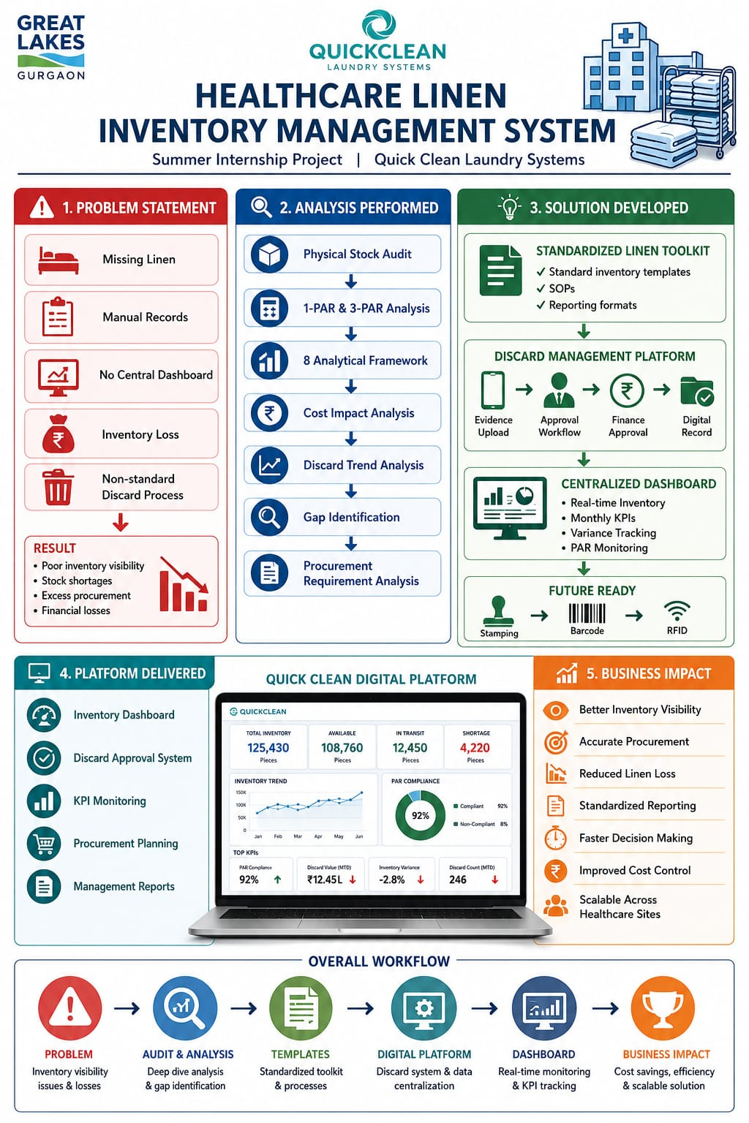

CHAPTER 1

ORGANISATION & INDUSTRY OVERVIEW

CHAPTER 1: ORGANISATION & INDUSTRY OVERVIEW

1.1 About Quick Clean Laundry Systems



Quick Clean Laundry Systems (operating as Quick Clean Private Limited), founded by Mr. Anshul Gupta, is among India’s leading providers of professional linen management and commercial laundry solutions, serving both the healthcare and hospitality sectors. The company operates large, mechanised on-premise and central laundry facilities and manages the complete lifecycle of linen from procurement and deployment, through daily washing and processing, to mending and final condemnation on behalf of its institutional clients.
In the healthcare segment, where this internship was based, Quick Clean’s operations are highly dependent on three things: accurate inventory tracking, disciplined discard management, and strict infection-control compliance. The processes are SOP-driven and require tight coordination between site teams (linen managers and floor staff), regional management, the central procurement and finance functions, and the client hospital. It was within this healthcare vertical specifically at the Lilavati Hospital & Research Centre site in Mumbai that the present project was undertaken.

1.2 The Indian Healthcare Linen and On-Premise Laundry Industry

Healthcare linen management in India has, over the last decade, shifted decisively from in-house hospital laundries towards specialised third-party operators working under rental or Build-Own-Operate (BOO) arrangements. Under this model the vendor owns the linen and the processing infrastructure, absorbs the capital expenditure, and bills the hospital on a usage- or volume-linked basis. For the hospital, this converts a lumpy capital decision and a non-core operational headache into a predictable operating expense with a defined service level; for the operator, it creates a recurring-revenue business whose profitability depends heavily on asset utilisation, linen longevity, and control over shrinkage.
The linen handled in a hospital is not a single commodity. A mid-sized multi-speciality hospital can hold tens of thousands of individual textile pieces spanning eighty or more categories general ward (“white”) linen, operating-theatre and CSSD (“green” and “blue”) linen, patient garments, staff uniforms, and high-value items such as blankets and surgeon gowns. Each category carries a different unit cost, a different wear profile, and a different clinical consequence if it runs short. This heterogeneity is precisely what makes accurate, item-wise inventory tracking both difficult and indispensable in the healthcare linen business.

1.3 Details of the Company

Attribute | Detail
Legal / Trade Name | Quick Clean Private Limited, trading as Quick Clean Laundry Solutions / Quick Clean Laundry Systems
Founded | 2010, by Mr. Anshul Gupta and Mr. Ankur Gupta
Headquarters | Gurugram, Haryana, India
Founder & CEO | Mr. Anshul Gupta
Business Model | Build-Own-Operate (BOO) On-Premise Laundry; equipment leasing; turnkey laundry projects; linen rental services
Sectors Served | Hospitality (luxury, upscale, and mid-market hotels) and Healthcare (hospitals and long-term care facilities)
Geographic Footprint | 36+ cities across India
Scale (reported) | 750+ employees; 3,000+ installed machines; 120+ five-star hotel and major healthcare clients; 600+ million kg of linen processed cumulatively
Sustainability Positioning | India's first ESCO-certified laundry company; ~450+ million litres of water saved and ~60 million kg of CO₂ emissions reduced (cumulative, reported)
Funding | ~US$5.89 million raised across multiple rounds, including Alkemi Growth Capital, Blue Ashva Capital, Delite Infrastructure, and a venture debt facility from Venture Debt Cos
Key Technology Partners | Electrolux Professional, Trevil, Rennai, LG, Dantebertoni, ARTMEC, HENSEN
Table 1: Key Facts - Quick Clean Laundry Solutions (Quick Clean Private Limited)

1.4 Definition of "Great Place to Work"

A "Great Place to Work" in the context of Quick Clean Laundry Systems is defined by an organizational ethos that emphasizes employee empowerment, continuous learning, and transparent communication. It is an environment where interns and entry-level staff are actively encouraged to challenge established processes and present evidence-based recommendations, and were leadership values data over assumptions.


1.5 Organizational Ethos and Work Culture

The work culture at Quick Clean is characterized by a strong alignment between academic rigor and practical operational application. The organization prioritizes a hands-on approach where operations teams actively engage with the laundry floor, bridging the gap between management theory and field realities.

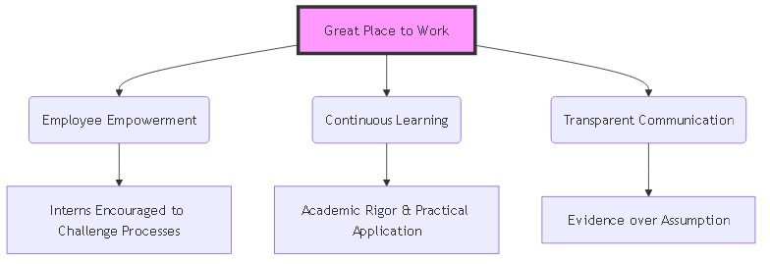
Figure 1: Quick Clean -Great Place to Work Structure

1.6 Company Culture & Structure

Quick Clean operates with a notably flat, founder-engaged management style for a company of its scale. This reflects a broader cultural pattern at Quick Clean in which senior leadership remains closely involved in operational and analytical work, even when it originates from interns, and in which cross-functional collaboration between Sales, Operations, Finance, Marketing/Analytics, and the Founder's Office is treated as the default way of getting work done rather than an exception.
This matrixed, cross-functional working style had a direct bearing on the methodology of this project: the analysis, dashboards produced during this internship were never built from a single data source, but were systematically triangulated across

Sales, Operations, and Finance inputs a structural reflection of how Quick Clean itself organises around its OPL business.
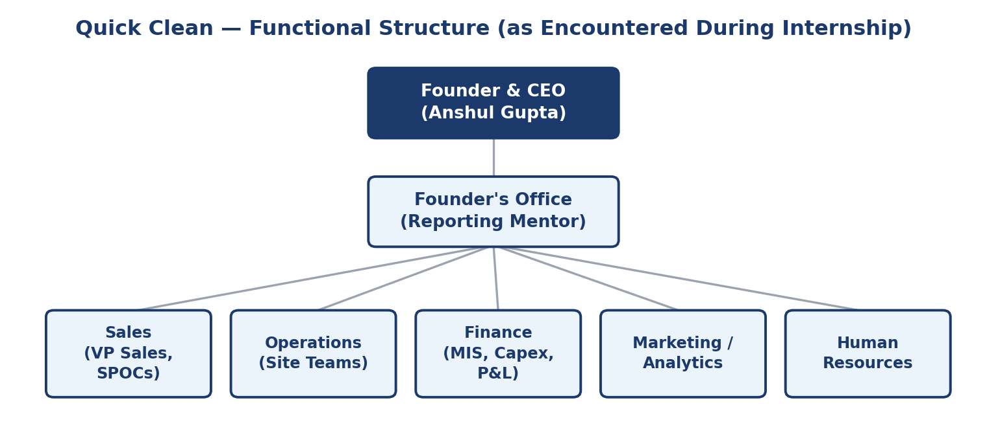
Figure 2: Quick Clean - Functional Structure (as Encountered During Internship)

1.7 Business Model

Quick Clean’s core commercial proposition at its healthcare sites is the linen-rental / BOO structure. The company deploys an agreed quantum of linen at the hospital, maintains it across its service life, replaces condemned items, and is contractually obligated to keep enough stock in circulation to meet the hospital’s daily demand at all times. The contract typically specifies, among other things, a tagging requirement so that ownership and circulation of every piece can be traced. As this report will show, the gap between what such a contract specifies and what is actually executed on the ground is exactly where inventory leakage and disputes arise.
Because the operator owns the linen, every untracked or unaccounted-for piece is a direct cost to Quick Clean, not to the hospital. The economics of the model therefore reward two disciplines above all: keeping linen in circulation long enough to recover its cost (longevity), and never losing sight of where each piece is (traceability). A weakness in inventory visibility attacks both of these simultaneously it inflates replacement purchasing and it erodes the margin on every site.
Quick Clean's core commercial proposition is the Build-Own-Operate (BOO) model, under which the company assumes full responsibility for capital expenditure, installation, staffing, and ongoing operation of laundry infrastructure at a client site, in exchange for a long-term, volume-linked service fee.
Quick Clean's revenue is generated through three principal streams.
- Per-kilogram service fees under BOO contracts - the dominant and most strategically important revenue stream, billed monthly based on actual linen volume processed at each site, typically under contracts of seven to twelve years with built-in annual price escalation clauses.

- Equipment leasing and laundry projects - a continuation of the company's original distribution-and-installation business, serving clients who prefer to own their own equipment but still require design, supply, installation, and commissioning support.
- Linen rental and ancillary services - supplementary revenue from linen supply and replacement programmes that complement the core OPL contracts at select sites.
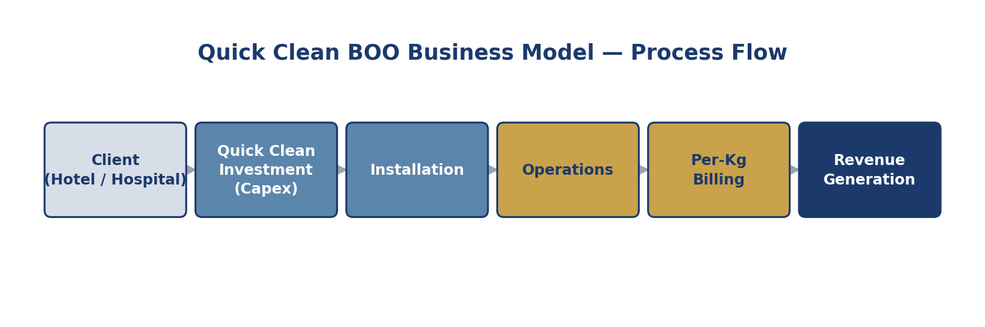
Figure 3: Quick Clean BOO Business Model -Process Flow

1.8 SWOT Analysis

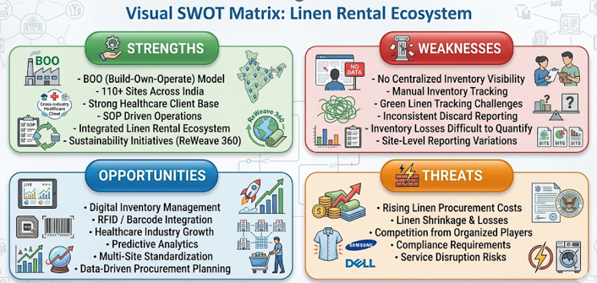
Figure 4: Quick Clean SWOT Analysis

- Strengths

Quick Clean possesses a strong and scalable business model through its Build-Own-Operate (BOO) approach, which enables ownership and lifecycle management of linen assets while generating recurring revenue. The company has established a significant presence across India through multiple healthcare and hospitality sites. Its expertise in healthcare laundry operations,

infection control, and linen rental management has helped build strong relationships with major healthcare institutions. The integrated service model covering linen procurement, rental, laundry operations, and management create a competitive advantage. Additionally, sustainability initiatives such as textile recycling and circular economy practices strengthen the company's market positioning.

- Weaknesses

During the internship project, inventory management emerged as a major operational challenge. The organization lacked a centralized system providing complete visibility of linen inventory across procurement, circulation, stock, discard, and losses. Inventory data was maintained through multiple manual records, creating inconsistencies and reducing reporting accuracy. Green linen movement within OT, CSSD, and Cath Lab environments could not be fully tracked after issuance, making consumption analysis difficult. Furthermore, discard approvals and reporting mechanisms were not standardized across sites, limiting lifecycle visibility and replacement planning.

- Opportunities

The project identified significant opportunities for operational transformation through digital inventory management. A structured Healthcare Linen Inventory Management System can improve inventory visibility, asset utilization, stock monitoring, and procurement planning. Future adoption of RFID, barcode, or QR-code tracking systems can provide real-time visibility of linen movement. The growing healthcare infrastructure sector in India presents additional expansion opportunities for Quick Clean, while data analytics can support predictive inventory planning and cost optimization.

- Threats

As Quick Clean owns the linen assets under its rental model, inventory losses directly impact profitability. Rising textile costs, increasing healthcare quality requirements, and competition from organized service providers pose strategic risks. Lack of accurate inventory visibility can result in stock shortages, over-procurement, and service disruptions. As the organization expands to additional sites, operational complexity and inventory control risks may increase without a robust management system.

1.9 Industry Analysis: Porter's Five Forces

Porter's Five Forces framework is applied below to the organised On-Premise Laundry segment of the Indian commercial laundry industry, within which Quick Clean competes.
- Threat of New Entrants: Moderate

Entering commercial laundry at a small, single-site scale is relatively easy, as evidenced by the large unorganised segment of India's USD 36 billion laundry market. However, replicating Quick Clean's BOO model at national scale requires substantial upfront capital, long-term relationships with hotel

chains and hospital groups, and the operational capability to manage installations across dozens of cities simultaneously all of which constitute meaningful barriers to large-scale entry. Quick Clean's existing footprint across 36+ cities and its track record with marquee clients such as Marriott provide a credibility moat that is difficult for a new entrant to replicate quickly.
- Bargaining Power of Suppliers: Low to Moderate

Quick Clean's primary suppliers are global laundry equipment manufacturers (Electrolux Professional, Trevil, Rennai, LG, and others) and chemical/detergent vendors. Because Quick Clean has historically operated as a large-scale distributor for several of these brands, and because laundry equipment and chemical inputs are available from multiple competing manufacturers, supplier power is generally low to moderate, with switching costs that are manageable relative to the scale of Quick Clean's purchasing.
- Bargaining Power of Buyers: High

Large hospitality groups and hospital chains and the Marriott relationship being the clearest example examined and also possess significant negotiating leverage given their scale, their ability to multi-source laundry services across regional vendors, and their increasing demand for measurable, ROI-backed service propositions rather than simple price quotes.
- Threat of Substitutes: High

The most direct substitute for Quick Clean's OPL model is the continued use of unorganised third-party commercial laundries or in-house laundry rooms staffed and equipped by the client itself both of which remain widespread. Linen rental-only models and partial in-house/partial outsourced hybrid arrangements represent additional substitutes. Quick Clean's primary defence against substitution is the demonstrated total-cost-of-ownership and service-level advantage of the BOO model once hidden costs (linen damage, working capital tied up in par stock, management overhead) are accounted for.
- Competitive Rivalry: Moderate to High

While the organised, technology-enabled OPL segment in India remains relatively young, competitive intensity is rising as facility management and laundry-as-a-service providers seek to capture the same hospitality and healthcare accounts. Quick Clean's points of differentiation documented are its all-inclusive total-cost-of-ownership pricing, its uptime and service-level guarantees, and increasingly, its sustainability credentials (ESCO certification, water and energy savings, and the Reweave 360 circular-linen programme), all of which this internship's analytical and platform-building work was designed to reinforce and communicate more systematically.
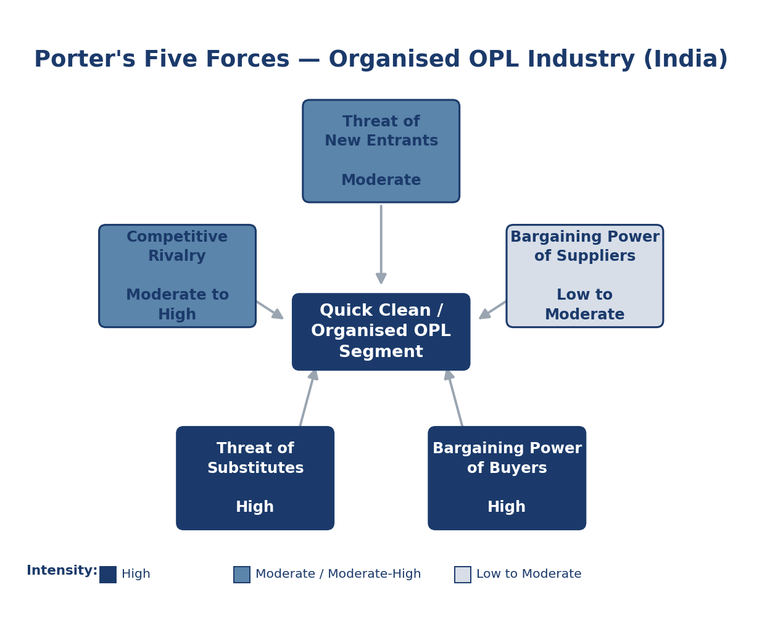
Figure 5: Porter's Five Forces - Organised OPL Industry

1.10 Model of Operations: Inputs, Process and Outputs

The operational core of the business is the laundry process itself. At Lilavati Hospital, the cycle begins when soiled linen is collected from the wards, operating theatres and the CSSD infected linen being segregated into red bags at source and transported to the laundry. There it is sorted by type, weight and infection status, weighed into batches (approximately 50 kg for general loads and 20 kg for infected loads), and washed across eight washing machines. The washed linen is then dried in four heat-pump dryers (about 37 kg capacity each), passed through flat-ironing and folding, and finally subjected to a quality check before being returned to circulation.
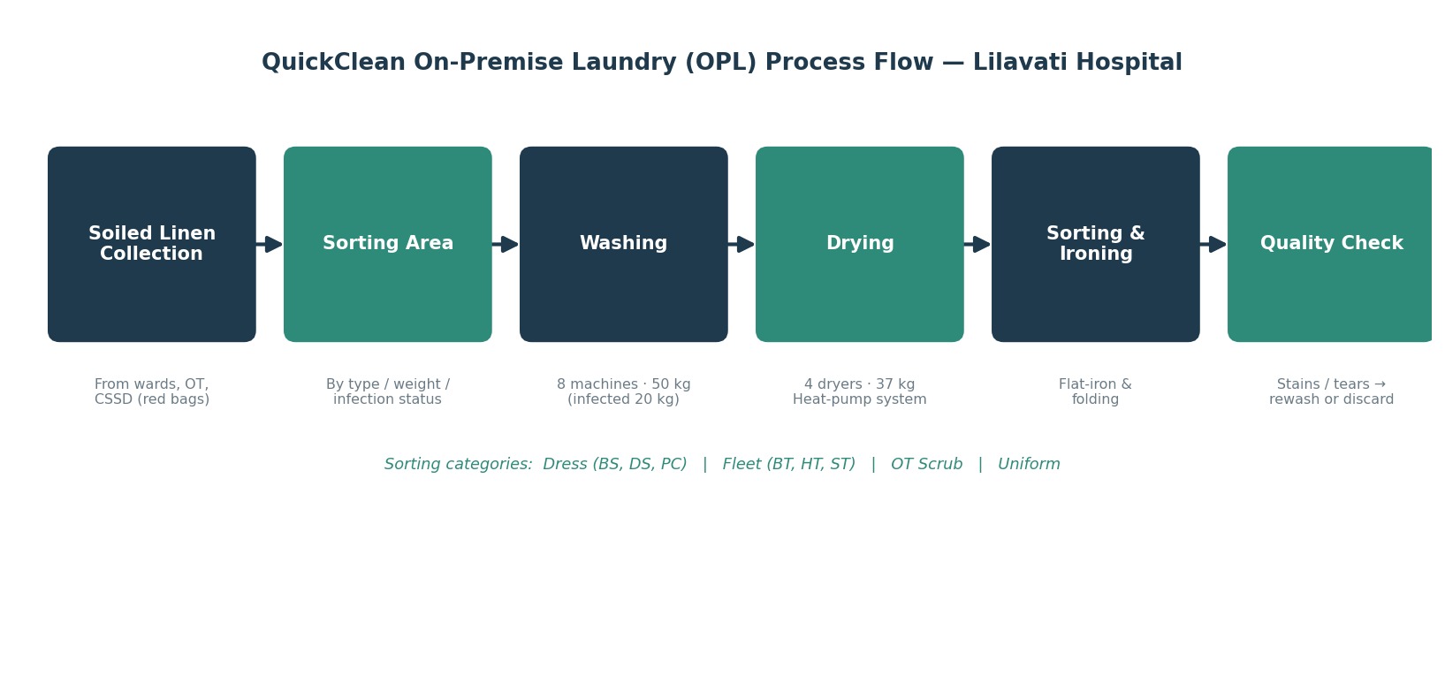Figure 6: The Quick Clean On-Premise Laundry (OPL) process flow observed at Lilavati Hospital

Viewed through an operations lens, the inputs to this system are soiled linen, water, energy, detergents and labour; the process is the wash-dry-iron-inspect cycle described above; and the output is hygienically clean, circulation-ready linen delivered back to the hospital floors. The quality-check stage is the critical control point: at this stage every piece is examined and routed to one of three destinations returned to circulation, sent for re-wash if a stain or odour persists, or pulled out for discard if it is torn or worn beyond use.

1.11 Title of the Project

“Operational Understanding of Healthcare Linen Rental Inventory Management System.”
The title reflects the dual intent of the project: first, to develop a deep, ground-level understanding of how linen inventory is actually managed within Quick Clean’s healthcare rental operations; and second, to convert that understanding into a workable system with templates, analyses, and a discard-approval workflow that the organisation can adopt across all of its hospital sites.

1.12 Need for the Study

When the Head of Operations assigned this project, healthcare linen inventory tracking was, in his own words, a “grey area” for the organisation. There was no single, trusted, item-wise picture of how much linen existed at a site, how much was genuinely in circulation, how much was sitting in the laundry, and how much had quietly gone missing. Procurement decisions, discard write-offs and client billing were all being taken on the basis of records that did not reconcile against one another. The need for this study therefore arose from a concrete operational pain: the company needed an evidence base that is defensible, repeatable method of counting and analysing linen before it could fix the underlying system.

Because physically auditing all of Quick Clean’s healthcare sites within the internship window was not feasible, a single representative site: Lilavati Hospital & Research Centre, Mumbai was selected as a pilot. The reasoning was deliberate: Lilavati is a large, multi-speciality, multi-floor hospital running both white and green linen streams, so a method that works there will generalise to smaller and simpler sites. The analysis, evidence and recommendations that follow are grounded in the Lilavati audit, but the templates and the analytical framework are designed to be applied, unchanged, at every Quick Clean healthcare site.

1.13 Objectives of the Study

The project was scoped around three primary objectives, each of which is addressed in a dedicated chapter of this report:
 | Objective
1 | To track linen procured, opening stock and discards, and to map the full linen lifecycle so as to establish accurate, real-time inventory visibility.
2 | To analyse the audited data -PAR position, variance, missing linen, procurement need, cost impact and discard behaviour and to identify the gaps in tracking and approval.
3 | To design an effective inventory tracking & reporting system, including standardised templates and a structured discard-approval workflow.
Table 2: The three project objectives and their treatment in this report

1.14 Scope of the Study

- Site scope. A complete physical stock audit of one pilot site: Lilavati Hospital & Research Centre, Mumbai conducted on 18 May 2026, covering both the White (general ward) and Green/OT (CSSD and operating-theatre) linen streams, including the VIP wing.
- Process scope. End-to-end mapping of the linen lifecycle from procurement and deployment through circulation, laundering, quality check and discard.
- Analytical scope. Eight structured analyses 1-PAR, 3-PAR, variance, PAR assessment, missing-linen, procurement, cost-impact and discard / trend analysis.
- Design scope. A standardised Excel-based linen-management toolkit, a digital discard-approval platform, a centralised inventory dashboard, and a phased linen-tagging roadmap.

1.15 Research Methodology

This study follows a single-site, mixed-method design that combines direct observation, primary physical counting, and quantitative reconciliation. The methodology proceeded in four stages. First, I spent the early weeks of the internship observing daily laundry operations and collecting linen records

from the linen managers, validating them against procurement and finance records. Second, a full physical stock audit was carried out at Lilavati on 18 May 2026, counting every linen item in three locations in circulation on the wards/floors, inside the laundry cycle, and in the reserve fresh-stock store. Third, the audited numbers were reconciled against a book figure derived from the previous month’s closing stock. Fourth, the reconciled data was passed through the eight analyses.
The reconciliation logic is the analytical backbone of the project and is worth stating explicitly. For every item, an expected closing stock was built by taking the opening stock (the previous month’s closing balance, since the audit fell on 18 May the April closing was used), adding any new purchases, and subtracting the month’s discards. This expected figure was then compared against the observed total physically counted during the audit. The difference between the two is the variance-the quantum of linen that is unaccounted for.
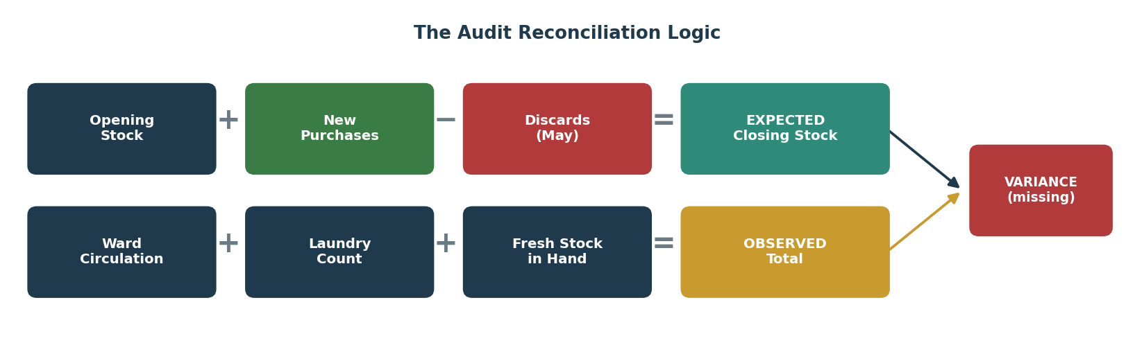
Figure 7: The audit reconciliation logic: Expected Closing Stock vs Observed Total → Variance

The six data sources that fed this methodology are summarised below.
Data Source | Content | Purpose
Physical Audit, 18 May 2026 | Item-wise ward circulation count + laundry count + fresh-stock count | Observed total; variance; status classification
Opening / Closing Records | Previous-month closing stock, purchases and discards | Expected closing stock (book figure)
Daily Floor-Issue Records | Item-wise quantity issued to each floor/ward per day, audit reference period | 1-PAR and 3-PAR baseline derivation (average daily issue)
Bed-wise Requirement Sheet | Bed counts by floor, OPD, RMO, relatives, emergency | 1-PAR and 3-PAR baseline derivation (legacy April comparison only)
PT Uniform & VIP Sheets | Patient-garment allocation by size, normal & VIP wards | Garment stock planning and size-wise gap
CSSD OT Requirement List | Morning + afternoon shift linen demand by item | OT daily demand vs. current stock gap
Table 3: The six primary data sources collected and audited during the project

1.16 Deriving the 1-PAR and 3-PAR Baseline

The 1-PAR/3-PAR analysis is the foundation on which every other analysis which is being built, so its method is stated explicitly here. For each item, the average quantity issued to the floor per day over the audit reference period was computed from the daily floor-issue records this average is, by definition, the 1-PAR: one day’s genuine requirement. Multiplying by three gives the 3-PAR, the operational ideal under which one day’s worth of stock can be simultaneously on the ward, in the laundry cycle and held in reserve without any of the three positions running empty. The 3-PAR is then compared against the observed total from the physical audit to produce the 3-PAR Gap: a positive gap is excess; a negative gap is shortage.
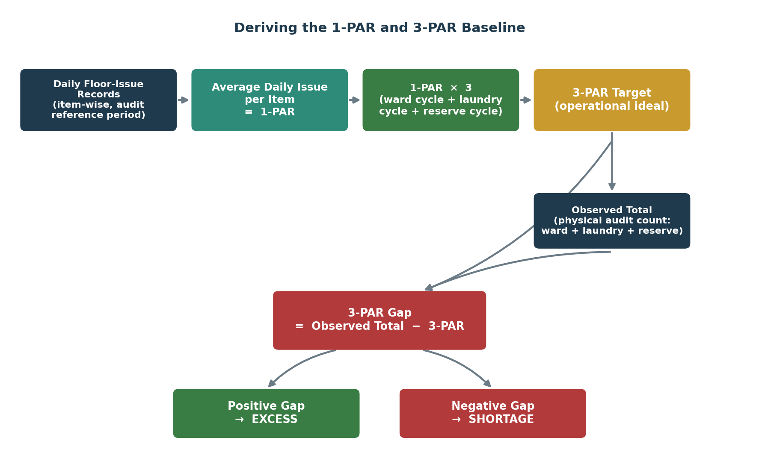
Figure 8: Methodology for deriving the 1-PAR and 3-PAR baseline from average daily floor-issue, and classifying the resulting gap as shortage or excess

1.17 Cost-Impact Analysis Methodology

The cost-impact analysis converts the physical gaps into rupee terms along two parallel tracks. The monthly cost of shortage takes the shortage quantity at any item (3-PAR minus observed) and prices the operational exposure it represents against the item’s average daily issue and unit cost. The annualised cost of missing linen takes the missing quantity the variance, i.e. expected closing stock minus observed total and multiplies it by the unit cost, and projects it across twelve months to show the recurring replacement burden if the current loss rate persists. Unit costs were supplied by the company; the resulting figures are intended to convey order of magnitude and direction, not audited financial values, and are read together with the missing-linen analysis.
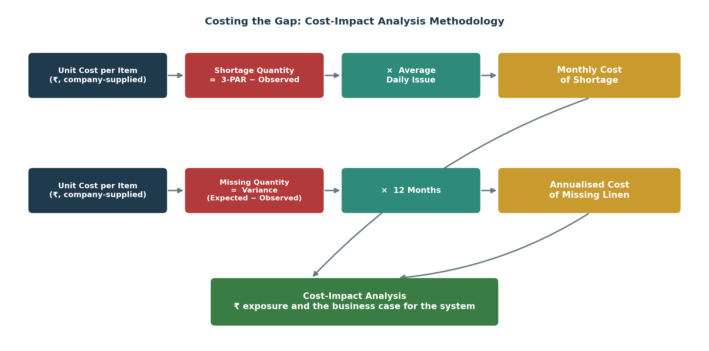
Figure 9: Methodology for the cost-impact analysis: pricing shortage and missing linen into a monthly and an annualised rupee exposure

1.18 Discard and Trend Analysis Methodology

Daily discard logs for both the White and Green/OT streams were collected for a four-month window (February to May 2026) and aggregated into an item-wise monthly discard count. Plotting these counts month-on-month surfaces the trend for each item, and dividing the monthly count by the number of days in the period gives the daily average discard rate. Each item’s rate was then benchmarked against its audited stock to classify it as High (more than 5%, warranting a fabric or wash-process review), Moderate (2-5%, normal wear to be monitored monthly) or Low (under 2%, lasting well) the same High/Moderate/Low bands used in the findings.
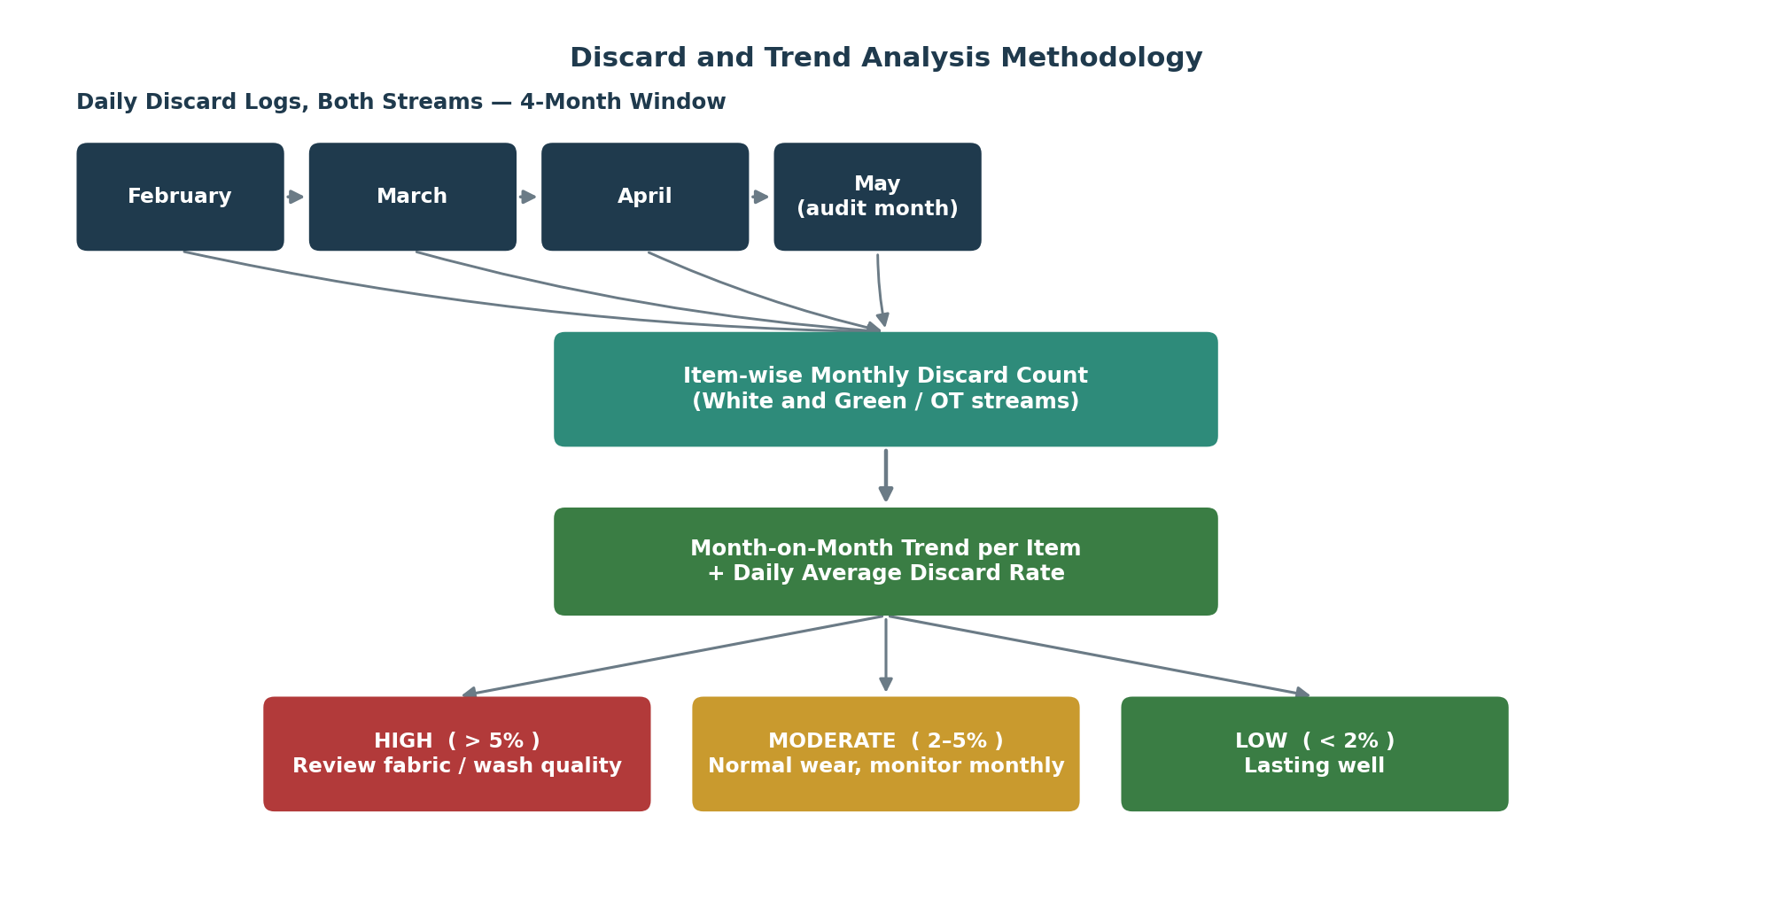
Figure 10: Methodology for the discard and trend analysis: four months of discard logs reduced to a daily average discard rate and a High/Moderate/Low severity band

1.19 Missing-Linen and Procurement (Requirement) Methodology

The missing-linen analysis starts from the same variance used throughout this report: expected closing stock minus observed total. Wherever this variance is positive, that quantity is treated as missing linen requiring replenishment in other words, the variance itself defines the procurement requirement. Multiplying the missing quantity by the item’s unit cost produces an estimated rupee value, which is then ranked across items to identify the most severe losses (the items where the company’s exposure is largest). In parallel, the missing quantity plus a 10% working buffer becomes the procurement quantity plan presented is the exact amount of each item that must be bought back to restore the 3-PAR position, with items already at or above 3-PAR generating a procurement requirement of zero.

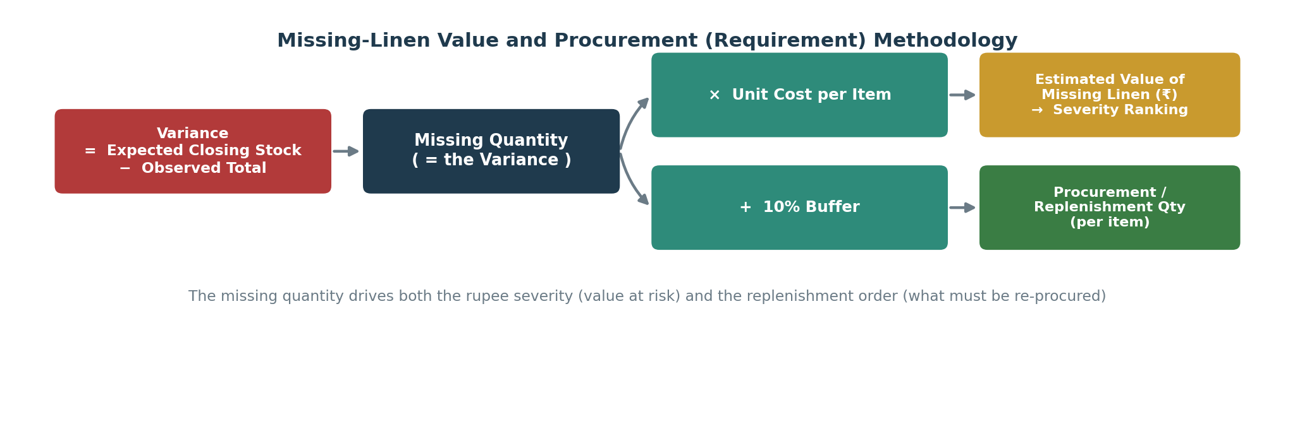
Figure 11: Methodology for the missing-linen value and procurement (requirement) analysis: variance drives both the severity ranking and the replenishment quantity

1.20 Tools and Technologies Used

Two distinct sets of tools underpin this project: the tools used to conduct the audit and build the analyses presented in this report, and the technologies specified for the inventory-tracking system proposed in following report. Both are summarised below for reference.
Tool / Technology | Purpose | Where used
MS Excel | Reconciliation of audit data; 1-PAR/3-PAR, variance, cost-impact and discard-rate calculations; data consolidation across sources | Research methodology
MS Word | Report compilation, formatting and version drafting | Throughout this report
Physical Audit Tally Sheets | Manual item-wise count across ward circulation, laundry-in-process and fresh-stock store | Physical audit, 18 May 2026
Standardised Excel Toolkit | Input-versus-calculation discipline; auto-computes PAR, variance, cost and status flags at source | Proposed system
Java | Digital discard-approval workflow application moving condemnation through the site → laundry manager → regional manager → head office chain | Proposed system
SQL Database | Data store for the discard-approval platform; retains photo/barcode evidence for finance-ready audit trail | Proposed system
Python (pandas) | Analytical layer that recomputes the eight analyses for each uploaded site on a common basis | Proposed system
Streamlit | Centralised, web-based inventory-tracking dashboard for portfolio-wide visibility | Proposed system
Barcode (Phase 2 tagging) | Item-level, scannable identity enabling per-piece issue/return/discard tracking | Proposed tagging roadmap
RFID (Phase 3 tagging) | Automated, contactless item-level tracking at scale once barcode adoption is established | Proposed tagging roadmap
Table 4: Tools and technologies used to conduct the project, and the technology stack specified for the proposed system

1.21 Limitations of the Study

- The audit was conducted at a single pilot site. While Lilavati is deliberately chosen as a complex, representative case, item-level numbers cannot be assumed identical at other sites; it is the method, not the specific quantities, that is generalisable.
- The opening stock used was the previous month’s reported closing balance. Where that earlier figure was itself miscalculated which the variance analysis in fact exposed the expected closing stock inherits that error. This is acknowledged in the analysis rather than hidden.
- For the Green/OT stream, the laundry-in-process count on audit day is nil since they are counted in KGs; the observed totals therefore represent a floor (minimum) rather than the full circulating quantity so we took the average linen being issued to the floor, making OT shortages a conservative estimate.
- Linen items were not tagged, so individual wash-cycle history could not be measured directly; discard behaviour was inferred from daily discard logs rather than per-item cycle counts.
The cost-impact figures use unit costs supplied by the company and standard assumptions; they are intended to indicate order of magnitude and direction, not audited financial values.

CHAPTER 2

LITERATURE REVIEW

CHAPTER 2: LITERATURE REVIEW

2.1 Introduction and Research Context

Healthcare linen management encompasses the procurement, processing, distribution, tracking and disposal of every textile item used in a hospital bed sheet, pillow covers, patient gowns, surgical drapes, towels and staff uniforms. Far from being a peripheral housekeeping function, linen services are deeply intertwined with patient safety, infection prevention and operational cost control. This literature review establishes the conceptual foundation for the inventory system designed in this project, drawing on peer-reviewed research, institutional SOPs, national accreditation standards and industry evidence. It deliberately moves from the clinical and definitional foundations of linen management, through the inventory and PAR-control theory at the heart of this project, to the technology and accreditation benchmarks that inform the recommendations.

2.2 Healthcare Linen Services: Scope and Key Concepts

Research on hospital linen and laundry operations (Gajuryal, 2023, B.P. Koirala Institute of Health Sciences) describes the laundry task cycle as a sequence of sorting, washing, drying, ironing, folding and delivery, with operating-theatre linen requiring additional sterilisation. Several concepts recur across the literature and form the vocabulary of any inventory system:
- Linen inventory - a systematic record of all linen used for patient care, infection control and daily operations. The study of OPD linen inventory at Christian Medical College (CMC), Vellore (Merlin & Ruth Mary, IJFMR, 2024) stresses that strict hygiene must be maintained through every stage of collection, sorting and washing.
- Linen condemnation - the formal removal of linen from active circulation once it is unusable due to stains, tears or infection-control requirements. The present project treats “discard” as synonymous with condemnation.
- Linen replacement - the issuance of new linen by central stores to replace condemned items so that approved stock levels are maintained.
- Centralised vs. departmentalised services - in centralised systems all linen is processed at a central laundry and distributed; in departmentalised systems each unit keeps its own marked supply. QuickClean’s on-premise model at Lilavati is effectively centralised at the site level.

2.3 Linen Management Protocols and Standard Operating Procedures

Mature healthcare systems codify linen handling in detailed SOPs. The Sydney Children’s Hospitals Network (SCHN) Linen Management Procedure (2024) provides a representative best-practice framework whose provisions map directly onto the gaps found in this project: only one day’s supply of linen may be stored at ward level on weekdays (over-stocking is treated as an infection risk); clean and soiled linen must be transported separately at all times; a colour-coded bag system segregates soiled linen by category; and clean linen found torn, stained or holed must be returned to linen services for re-crediting. Crucially, the SCHN framework mandates that the central linen department maintain a defined supply buffer- the institutional equivalent of a PAR level.

In the Indian context, the National Accreditation Board for Hospitals & Healthcare Providers (NABH, 6th Edition, 2025) and the National Health Systems Resource Centre’s guidelines on CSSD and Mechanised Laundry establish “segregation at source” as a binding principle: used linen must be sorted into soiled and non-soiled at the point of removal, discarded only into marked bags, and never mixed or thrown on the floor. These national standards reinforce that the discard and segregation workflows being designed for Quick Clean are not merely operational niceties but compliance requirements.

2.4 Inventory Variance in Healthcare Linen: Empirical Evidence

The empirical literature consistently finds that maintaining accurate linen stock across departments is genuinely hard, even for elite institutions. The CMC Vellore study (Merlin & Ruth Mary, 2024) examined OPD linen inventory at one of India’s most respected hospitals and an institution with over fifty years of laundry experience and a substantial equipment fleet and still found significant discrepancies between approved and actual stock across every OPD floor and department. The discrepancies were attributed to uncoordinated redistribution, the absence of real-time tracking and weak inter-departmental communication. The study’s recommendations introduce inventory software, create communication channels, train staff and review stock regularly align almost exactly with the objectives of the present project, and demonstrate that the variances found at Lilavati are a structural feature of the sector rather than an isolated failing.

2.5 Infection Control as a Driver of Linen Standards

Infection prevention and control is the most important quality driver in healthcare linen. Sarla (2023), studying the environmental implications of hospital laundry, notes that hospital linen is routinely contaminated with bodily fluids and therefore requires handling protocols fundamentally different from hospitality laundry. The deliberate use of white linen in general wards aids visual detection of contamination, while the controlled use of green linen in operating theatres helps identify blood staining a colour logic that directly explains the White and Green streams analysed in this report. National standards (Ethiopia Ministry of Health, Chapter 8; the Australian/New Zealand Standard AS/NZS 4146) translate this imperative into validated wash temperatures, water quality controls and chemical dosing. For Quick Clean, the practical consequence is that discard decisions must be triggered not only by physical wear but also by infection-control condemnation a data field the proposed system must capture.

2.6 The Rental / BOO Lifecycle and the Visibility Problem

Under the rental model the vendor owns the linen and bears full lifecycle responsibility a fundamental difference from the client-owned model. The vendor must, at any moment, know how much linen is deployed at each site, how much is in processing, how much is in transit, and how much has been condemned. The lifecycle is a closed loop: procurement and deployment, soiled collection at the point of care, transport to the laundry, processing, quality inspection, storage and redistribution. Any leakage at any node of this loop produces inventory shrinkage, inflated replacement cost and the risk of linen unavailability at the hospital.

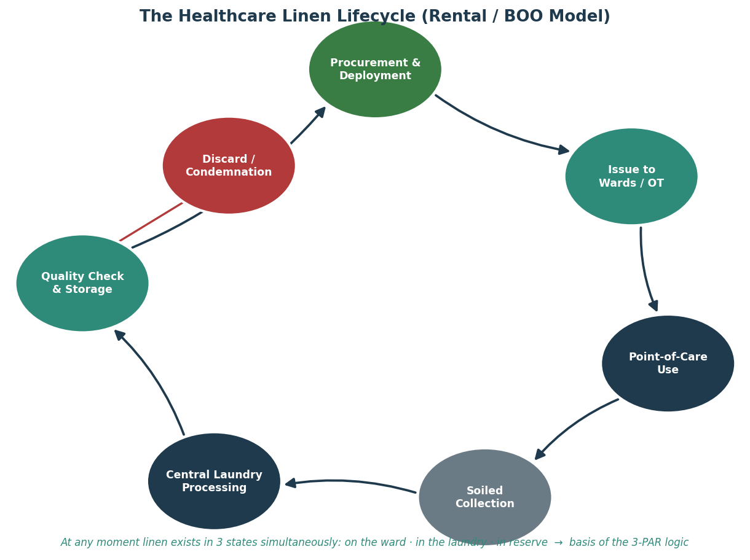
Figure 12: The closed-loop healthcare linen lifecycle under the rental / BOO model
Frameworks for supportive hospital services (Desai) identify inventory visibility as the single most critical operational challenge in multi-site rental operations, and recommend a combination of PAR-level controls at each site, centralised visibility dashboards and regular physical-to-book reconciliation precisely the three-part solution architecture adopted in this project.

2.7 PAR-Level Theory: The Heart of Linen Inventory Control

The organising principle of linen inventory control is the PAR (Periodic Automatic Replenishment) system. The 1-PAR is the minimum quantity required to serve all active linen-requiring units for one full day. The operational ideal, however, is 3-PAR three times the daily requirement because at any instant linen is simultaneously in three states: on the ward with patients, in the laundry being processed, and in the reserve, store awaiting issue. If total stock falls below 3-PAR, one of these three cycles begins to run empty, and a ward will eventually face a mid-shift stockout. This three-cycle logic is the analytical lens through which every shortage and excess in Chapter 4 is interpreted, and it converts the abstract idea of “enough linen” into a precise, item-wise, countable target.

2.8 Technology in Linen Tracking: Barcode and RFID

A substantial body of industry evidence quantifies what happens when item-level tracking is absent and what is recoverable when it is introduced. Market research on RFID linen tracking indicates that hospitals without automated tracking lose an estimated 15-25% of their linen inventory annually, and that a 300-bed facility can manage upwards of 20,000 individual pieces (Dataintelo, 2026). Implementations of RFID and RAIN-RFID systems are reported to cut linen losses dramatically from around 15% to as low as 3% in some cases, and by 30-40% in others with one case study citing single-year savings of roughly USD 652,000 from an RFID-based utilisation system (RFID Tag, 2026; Quick Smart Wash, 2026). Industrial RFID laundry tags are designed to survive 200+ wash cycles, enabling per-item wash-count tracking and automatic retirement of linen that has reached its maximum recommended cycles, and they allow PAR levels to be set on real usage data rather than estimates.

The most strategically useful insight from this literature is that tracking separates perception from reality: hospitals frequently assume theft drives loss, when the data shows it accumulates in small increments accidental disposal with red-bag waste, ward over-stocking, and linen leaving with patient transfers (CORE Linen Services, 2026). This is exactly the diagnostic capability that the absence of tagging denied Quick Clean at Lilavati, and it directly informs the phased tagging roadmap recommended.

2.9 Accreditation and Quality Standards

Independent accreditation provides the external benchmark against which a healthcare laundry’s processes can be validated. In North America, the Healthcare Laundry Accreditation Council (HLAC) accredits laundries against inspected standards covering facility design, policies, training and customer relationships, with accreditation valid for three years; TRSA’s Hygienically Clean Healthcare certification adds microbiological testing, requiring two consecutive rounds of testing demonstrating negligible levels of harmful bacteria (TRSA; HLAC, 2024). These frameworks, endorsed by bodies such as the CDC, establish documented SOPs, quality-assurance manuals and evidence-based processes as the markers of a credible healthcare laundry – a useful aspiration for QuickClean and a natural anchor for the standardised documentation this project introduces.

2.10 Key Operational Metrics and Benchmarks

The literature converges on a standard set of metrics for measuring linen-operation performance, which informed the KPI design in this project: cost per kilogram processed; turnaround time (soiled collection to clean delivery); inventory variance (book vs. physical, which the CMC study shows can run simultaneously positive and negative within one institution); linen loss rate, with an industry-accepted band of roughly 2–5% per annum; machine-utilisation rate; and the count of pending discard authorisations, whose growing backlog signals a workflow bottleneck that distorts book stock. The variance and loss-rate benchmarks in particular provide the yardstick against which the Lilavati findings are judged.

2.11 Research Gap and Implications for the Project

Taken together, the literature establishes three things. First, linen inventory variance is endemic, well-documented and costly, even in mature institutions. Second, the recognised remedies PAR-level control, standardised records, formal discard authorisation, regular physical-to-book reconciliation and, ultimately, item-level tracking technology are well understood in principle. Third, and critically, there is a persistent gap between these documented best practices and their disciplined execution on the ground in a multi-site Indian rental operation. It is precisely this execution gap that this project addresses for QuickClean: not by proposing untested theory, but by applying established inventory principles to a real, audited site, quantifying the cost of the gap, and packaging the remedy into templates and workflows the organisation can actually deploy.

2.12 Literature vs. Practice: A Comparative Synthesis

Section 2.11 argued that the literature is well-developed in principle but inconsistently executed on the ground. The table below makes that comparison explicit, theme by theme, against what was actually found or implemented at Lilavati. Where the project’s scope did not allow a literature claim to be directly tested most notably the RFID/barcode loss-reduction figures, which come from other organisations’ implementations rather than a Quick Clean pilot this is recorded as a challenge for future work rather than forced into a comparison the data cannot support.

Literature Theme | What the Literature Reports | Finding / Current Practice at Lilavati | Comparability
Inventory variance is endemic (CMC Vellore, 2024) | Significant stock discrepancies found even at a mature, well-resourced hospital laundry | Confirmed -White and Green/OT streams both show items simultaneously in excess and shortage | Directly comparable
3-PAR / three-cycle theory | Three times daily need is the accepted operational ideal (ward + laundry + reserve) | Adopted as the core analytical lens | Directly comparable
RFID / barcode loss reduction (Dataintelo; RFIDTag, 2026) | Case studies report loss cut from ~15% to ~3–9%, with six-figure annual savings | Quick Clean has not yet implemented tagging at Lilavati; no before/after data exists on site | CHALLENGE cannot be benchmarked until the Phase 2/3 tagging roadmap is piloted
Accreditation standards (HLAC; TRSA Hygienically Clean) | Independent microbiological testing and 3-year accreditation cycles | Lilavati is not currently benchmarked against an independent accreditation standard | CHALLENGE accreditation audit was outside this project’s scope
Linen loss-rate benchmark (2–5% per annum, industry-accepted) | Defines an acceptable annual loss band | A single month’s gap at one site (~4,156 units, ₹10.9 lakh) is materially above this band on an annualised basis | Directly comparable
Segregation-at-source SOPs (NABH; SCHN, 2024) | Mandates colour-coded bag segregation and separate clean/soiled transport | Observed and largely followed in practice during the lifecycle mapping | Directly comparable
Condemnation criteria (SOP literature: tears, thinning, staining, infection control) | Discard should be triggered by tears, thinning, persistent staining and infection-control reasons | Only torn linen was actually being condemned in practice | Directly comparable confirms an execution gap
Table 5: Literature themes compared against findings and current practice at Lilavati, with items that could not be directly benchmarked recorded as challenges for future work

Read together, the comparable rows confirm that Lilavati’s problems are not an isolated failing but a documented, sector-wide pattern which is what makes the templates and workflows proposed in following report, a generalisable response rather than a one-site fix. The two items recorded as challenges are flagged honestly rather than glossed over: they are precisely the questions the phased tagging roadmap and a future accreditation exercise are designed to answer once the system in this report is deployed.

CHAPTER 3

LINEN LIFECYCLE MAPPING & GAP IDENTIFICATION

CHAPTER 3: LINEN LIFECYCLE MAPPING & GAP IDENTIFICATION

3.1 The Pilot Site: Lilavati Hospital & Research Centre

Quick Clean Private Limited manages the complete linen lifecycle for Lilavati Hospital & Research Centre, Mumbai, washing, drying, ironing, mending, distribution and inventory tracking across more than eighty linen categories. Two distinct streams are managed in parallel: White Linen, serving the general patient wards from the ground floor through the twelfth floor and including the VIP wing; and Green / OT Linen, serving the operating theatres, the CSSD and the surgical staff. The site was selected as the pilot precisely because its scale and complexity make it the hardest case: a method proven at Lilavati can be applied with confidence at any smaller Quick Clean healthcare site.

3.2 Mapping the Linen Lifecycle

The first task was to map, from direct observation, how a single piece of linen actually moves through the system. Soiled linen with infected items segregated into red bags at the point of care in the wards, OTs and CSSD arrives at the laundry, where it is sorted and weighed before washing. After the wash- dry- iron cycle it reaches the quality-check stage, where each piece is routed to one of three outcomes: returned to circulation, sent for re-wash, or pulled for discard if torn or worn. Discarded items are logged; mended items are recorded separately. This lifecycle, mapped and observed first-hand on the floor, is sound in its physical design. The failure is not in how linen moves it is in how that movement is recorded.

3.3 The 1-PAR Baseline: Deriving the Demand Anchor

Before any shortage or excess could be judged, a defensible demand baseline had to be built. The 1-PAR for each item was derived empirically from the average quantity of that item issued daily to the floor over the audit reference period not by working top-down from a bed-count ratio. This usage-based approach captures what the wards actually consume in practice, including swing demand created by occupancy, OPD load and VIP allocation, which a static per-bed ratio cannot. The 3-PAR target the operational ideal that keeps one day’s stock simultaneously on the ward, in the laundry and in reserve is simply three times this average-issue figure. This is the baseline used throughout the audit and carried into every analysis.

Item | 1-PAR (Average Daily Floor-Issue) | 3-PAR (1-PAR × 3)
Bed Sheets | 806 | 2,418
Draw Sheets | 189 | 567
Pillow Covers | 375 | 1,125
Bath Towels | 307 | 921
Hand Towels | 86 | 258
PT Pants | 321 | 963
PT Shirts | 324 | 972
White Pants | 55 | 165
White Shirts | 65 | 195
White Gowns | 63 | 189
Blankets | 166 | 498
Sponge Towel | 123 | 369
VIP Bed Sheet | 67 | 201
VIP Draw Sheet | 16 | 48
VIP Pillow Cover | 42 | 126
VIP Bath Towel | 31 | 93
VIP Hand Towel | 29 | 87
VIP Pants | 16 | 48
VIP Shirts | 25 | 75
VIP Blankets | 26 | 78
Table 6: 1-PAR (average daily floor-issue) and 3-PAR target by item, White and VIP linen, Lilavati Hospital - the baseline used throughout this audit (figures rounded to the nearest whole unit)

For context, procurement’s prior (April) approach had instead worked top-down from bed counts using a fixed per-bed linen ratio, shown in Table 7 below for comparison. The two figures diverge sharply for several items, which is itself evidence of why a usage-based baseline was needed.

Unit Category | Beds | Bed Sheets | Draw Sheets | Pillow Cover | Towels | Blankets
Patient Beds | 264 | 792 | 264 | 528 | 264 | 264
Relative Beds | 159 | 318 | 0 | 159 | 159 | 159
OPD / Daycare | 157 | 157 | 157 | 157 | 25 | 10
RMO Rooms | 93 | 93 | 0 | 93 | 0 | 93
Basement Visitors | 73 | 73 | 0 | 73 | 0 | 73
Mother Room | 10 | 20 | 0 | 10 | 10 | 10
On-call Doctors | 12 | 12 | 0 | 12 | 12 | 12
Emergency / Stretcher | 31 | 66 | 14 | 42 | 0 | 21
TOTAL (1-PAR) | 799 | 1,531 | 435 | 1,074 | 470 | 642
Table 7: Legacy April bed-wise PAR estimate, Lilavati Hospital superseded by the average-issue baseline in Table 7 above and shown here only for comparison (VIP wing: 56 beds → 224 bed sheets, 112 draw sheets, 224 pillow covers, 224 towels, 168 blankets)

Replacing the bed-wise estimate with an average-issue-derived baseline is significant in itself: it ties the PAR figure to actual ward consumption rather than theoretical bed capacity, capturing real demand patterns occupancy swings, OPD load, VIP allocation that a static per-bed ratio cannot. Asin following report, the difference between the two approaches exposed systematic over- and under-estimation in the figure’s procurement had previously been working with.

3.4 Gaps Identified During the Audit

The physical audit and the process observation together surfaced six distinct, mutually reinforcing gaps in the current tracking and approval system. Each is described below
- No Accurate, Reconciled Stock Count
There was no single trusted figure for how much linen actually existed at the site. The opening stock carried forward from April did not reconcile against a physical count items were variously in circulation, in the laundry, in reserve, or simply missing, and no process brought these together. The audit’s central contribution was to reconstruct a true observed total (ward circulation + laundry + fresh stock) and to test it against the book figure, thereby exposing that the earlier April closing stock was itself miscalculated.
- Mismatched Item Names Across Templates

The same physical item was recorded under different names in different registers one name on the daily floor-issue sheet, another on the inventory-tracking sheet, another on the discard sheet, and yet another during fresh-stock counts. Because the names did not match, item-wise quantities could not be aggregated reliably across templates, and any attempt at a clean per-item calculation broke down. This single inconsistency quietly corrupts every downstream number.

- Wrong Column Entries and Misinterpreted Breakdowns

While column totals often matched the audit, the item-wise breakdown beneath them did not: quantities were frequently entered against the wrong item, so the aggregate looked correct while the line-item PAR data was unreliable. For a PAR-driven system this is fatal the entire value of PAR analysis lies in the item-level detail, not the total.

- No Size-wise Bifurcation

This is the most consequential data gap. Patient garments (pants, shirts, gowns) all exist in sizes from Small through Jumbo, yet the floor-issue, inventory and discard templates record them only at the item level (“Patient Pants”) with no size split. When a discard sheet records “Patient Pants = 56”, procurement cannot tell whether the small, medium, large or XL stock has been depleted, so the reorder and any PAR calculation is built on guesswork. The author’s comparison of the current discard template against a proposed size-bifurcated template makes the lost information visible at a glance.
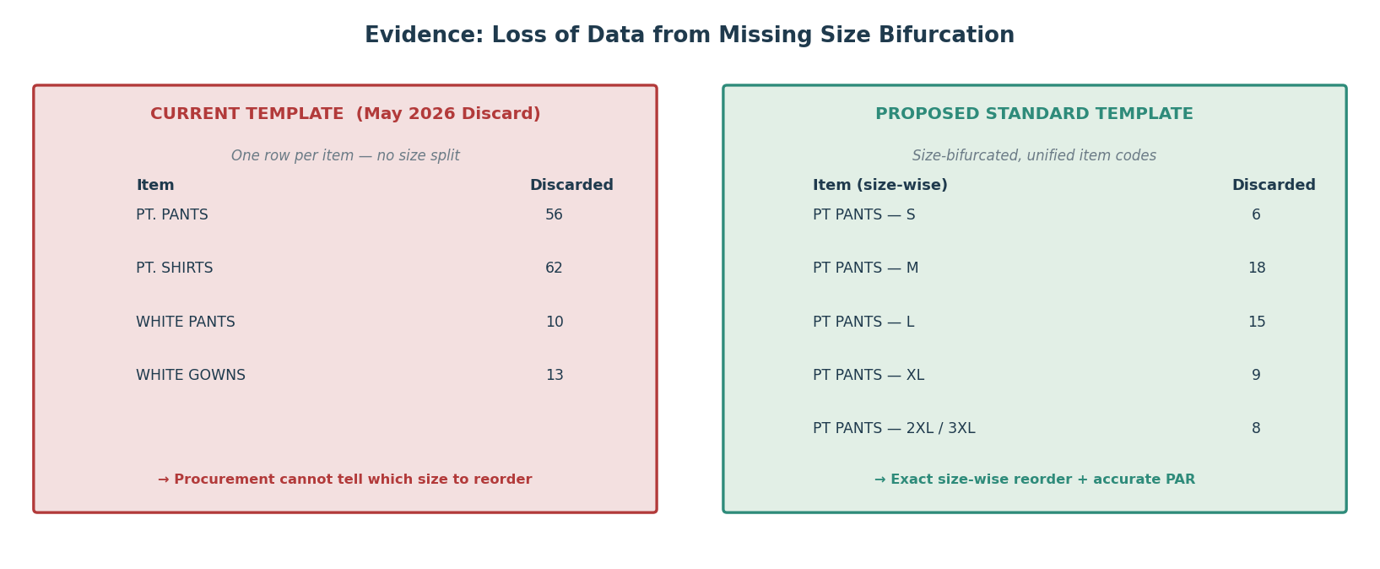
Figure 13: Evidence of data loss: the current item-only discard template (left) versus the proposed size-bifurcated standard template (right)

- Ineffective and Non-compliant Tagging

Although the client contract specifies a tagging requirement, it was not being followed in practice. Where tagging existed, it captured only a month/year stamp and was not used for wash-cycle tracking or to trigger discard. The practical result is that Quick Clean cannot reliably state which pieces are present at the hospital and which have gone missing and there is simply no per-item identity to count against. This both breaches the contract and removes the foundation on which any accurate loss measurement would rest.

- An Incomplete Discard System

In practice, only torn linen was being discarded, whereas the SOP envisages condemnation for thinning, persistent staining and infection-control reasons as well. Under-condemning keeps worn, patient-facing linen in circulation a quality and infection-control concern while simultaneously distorting the discard data on which procurement relies. Compounding this, discard write-offs lacked documented evidence, which had in the past led the finance team to withhold approval, creating disputes and a backlog.

- Synthesis: From Gaps to a System Brief

These six gaps are not independent faults; they form a single failure chain. Mismatched names and missing size bifurcation corrupt the item-level data; wrong column entries corrupt it further; the absence of tagging removes any independent check; under-condemning and undocumented discards corrupt the outflow data; and the combined effect is that no accurate, reconciled stock count is possible. The practical brief that emerges for the system design is therefore precise: standardise item names and add size bifurcation across all templates; enforce disciplined, evidence-based daily entry; introduce a phased tagging mechanism; and digitise the discard-approval chain so that every condemnation carries auditable evidence. Before designing that system, however, the cost of leaving the gaps unaddressed had to be quantified.

CHAPTER 4

INVENTORY ANALYSIS & QUANTIFIED FINDINGS

CHAPTER 4: INVENTORY ANALYSIS & QUANTIFIED FINDINGS

4.1 The Eight-Analysis Framework

To convert raw counts into decisions, the audit data was passed through eight complementary analyses. Each answers a different management question, and together they move from “how much do we have” to “how much is it costing us and what should we do.”
Analysis | Management question it answers
1-PAR Analysis | What is one day’s linen requirement per item, and how many days does current stock cover?
3-PAR Analysis | Against the operational ideal (3× daily need), is each item in shortage or excess?
Variance Analysis | Expected vs. observed: how much linen is unaccounted for / missing?
PAR Assessment | Were the April PAR estimates set too high or too low versus actual usage?
Missing-Linen Analysis | What is the rupee value of the missing linen, ranked by severity?
Procurement Analysis | Exactly how much of each item must be bought to restore 3-PAR (with buffer)?
Cost-Impact Analysis | What is the monthly cost of shortage and the annual cost of missing linen?
Discard & Trend Analysis | Which items wear out abnormally fast, and is attrition rising or falling?
Table 8: The eight analyses and the decision each one supports

4.2 White Linen Analysis

- 1-PAR and 3-PAR Position

For each item the observed total (ward circulation + laundry + fresh stock) was compared against the 3-PAR target derived from the actual May floor-issue average. The 3-PAR Gap is the decisive output: a negative gap means the item cannot complete all three cycles without a shortfall in plain terms; a ward will run short mid-shift. The table below presents the headline items.

Item | Opening | Discard | Observed | 3-PAR | 3-PAR Gap | Status
Bed Sheets | 2,362 | 168 | 2,476 | 2,418 | +58 | Excess
Draw Sheets | 690 | 116 | 758 | 567 | +191 | Excess
Pillow Covers | 1,498 | 53 | 1,507 | 1,125 | +382 | Excess
Bath Towels | 540 | 21 | 809 | 921 | -112 | Shortage
Hand Towels | 564 | 12 | 343 | 258 | +85 | Excess
PT Pants | 968 | 56 | 834 | 963 | -129 | Shortage
PT Shirts | 928 | 62 | 883 | 972 | -89 | Shortage
White Pants | 653 | 10 | 566 | 165 | +401 | Excess
White Shirts | 657 | 10 | 536 | 195 | +341 | Excess
White Gowns | 269 | 13 | 342 | 189 | +153 | Excess
Blankets | 775 | 11 | 643 | 498 | +145 | Excess
Sponge Towel | 230 | 0 | 149 | 369 | -220 | Shortage
Table 9: White-linen 3-PAR position, Lilavati Hospital (18 May 2026)

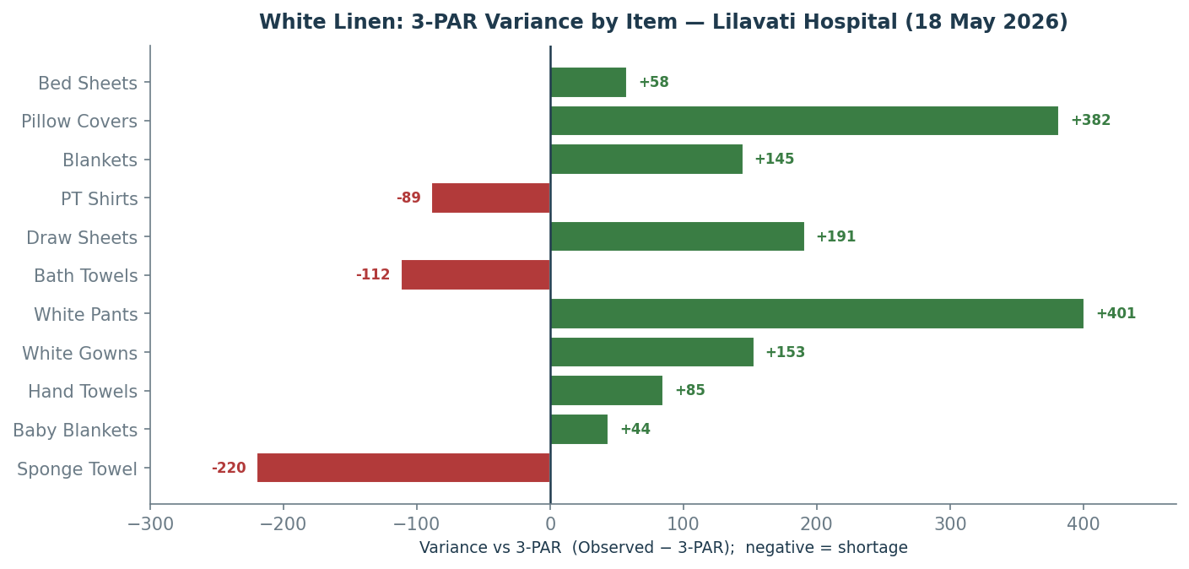
Figure 14: White line: variance against the 3-PAR target by item (negative = shortage)

The pattern is revealing. The white stream is not uniformly short it is simultaneously over-stocked in some categories (white pants +401, pillow covers +382, white shirts +341) and genuinely short in others (sponge towels =220, PT pants =129, bath towels =112). This co-existence of excess and shortage within the same stream is the classic signature of a tracking failure rather than a simple budget shortfall: the linen exists, but it is mis-positioned and mis-counted. It also means the remedy is not simply “buy more” it is to re-balance and to fix the counting.

- VIP Wing: A Uniform Shortage

The VIP wing (11th floor, A & B) is analysed separately because its shortage carries a different consequence a VIP stockout reaches hospital management directly as a patient-experience failure. Here the pattern is unambiguous: all eight VIP categories are in shortage at the 3-PAR level simultaneously, indicating a structural mismatch between the PAR set when the wing launched and its current occupancy.

VIP Item | Observed | 3-PAR | 3-PAR Gap | VIP Item | Observed | 3-PAR | 3-PAR Gap
Bed Sheet | 268 | 201 | +67 | Hand Towel | 138 | 87 | +51
Draw Sheet | 48 | 48 | 0 | Pants | 311 | 48 | +263
Pillow Cover | 385 | 126 | +259 | Shirts | 343 | 75 | +268
Bath Towel | 321 | 93 | +228 | Blankets | 67 | 78 | -11
Table 10: VIP-linen 3-PAR position. Note: against the April bed-wise estimate (3-PAR of 474-768 per item) every VIP category is deeply short the May floor-issue 3-PAR shown here is far lower, itself evidence of suppressed issue counts

- Variance: Quantifying the Missing

The variance analysis subtracts the observed total from the expected closing stock. A positive variance means items are unaccounted for. In the white stream, several categories returned large positive variances requiring investigation: white shirts +111, blankets +121, sponge towels +81, white pants +77 and PT pants +78, alongside a striking hand-towel excess of 209 units counted beyond expectation. Crucially, where the observed count exceeded the expected figure (a negative variance), this was not a windfall it was direct evidence that the April opening stock had been under-recorded, confirming the miscalculation that’s been flagged.

- PAR Assessment: Testing the April Estimates

The PAR assessment compared the actual 3-PAR (from real May floor issue) against the 3-PAR that procurement had estimated in April. The results expose systematic estimation error. In the white stream, high-volume staples such as bed sheets, pillow covers, PT pants and PT shirts where over-estimated procurement had been indenting for more than the floor actually consumed while several items (hand towels, white pants, white shirts, white gowns, baby blankets) were under-estimated, meaning their indents were structurally insufficient. In the VIP wing, all eight categories were over-estimated against the bed-wise April figure. An estimate that is wrong in both directions, item by item, is not a usable basis for procurement which is the core argument for the standardised, usage-driven PAR the project introduces.

4.3 Green Linen Analysis

Green linen is the highest-stakes category in the audit: an OT linen shortage can delay a surgical procedure, not merely a bed change. The same PAR-variance technique applies, but the numbers are more severe because the laundry-in-process count on audit day was effectively zero the observed totals capture only ward circulation and reserve store, and therefore represent a floor, not the full circulating quantity. Every green shortage below is thus a conservative estimate.

Item | Opening | Discard | Observed | 3-PAR | 3-PAR Gap | Status
Green Bed Sheet | 650 | 202 | 614 | 1,002 | -388 | Shortage
Green Draw Sheet | 458 | 134 | 367 | 540 | -173 | Shortage
Green O.P. Towel | 815 | 117 | 747 | 975 | -228 | Shortage
Blue O.P. Towel | 1,755 | 172 | 950 | 1,221 | -271 | Shortage
Surgeon Gown | 555 | 22 | 515 | 327 | +188 | Excess
XL Gown | 892 | 31 | 600 | 408 | +192 | Excess
Nurse Gown | 170 | 7 | 182 | 204 | -22 | Shortage
Turkish Towel | 295 | 10 | 332 | 555 | -223 | Shortage
Green Shirt (M) | 450 | 11 | 430 | 582 | -152 | Shortage
Navy Pant (M) | 305 | 8 | 72 | 231 | -159 | Shortage
Medium Towel (S) | 2,711 | 138 | 4,065 | 1,443 | +2,622 | Excess
Skin Towel (F) | 2,312 | 119 | 2,141 | 1,287 | +854 | Excess
Table11: Green / OT-linen 3-PAR position: selected high-impact items (18 May 2026)

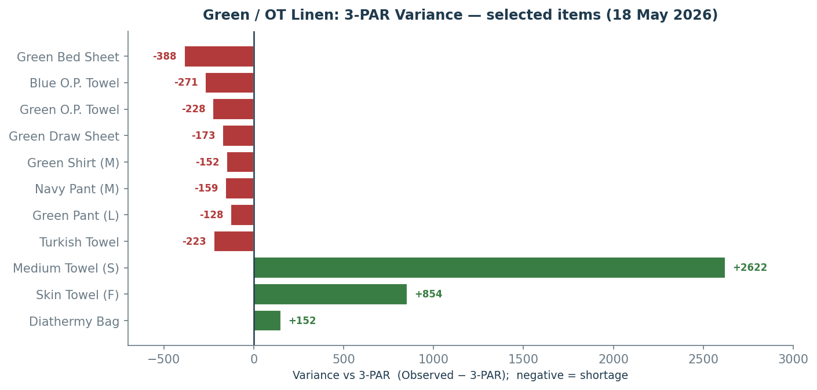
Figure 15: Green / OT linen: variance against the 3-PAR target for selected items
The OT picture is more alarming than the ward picture. Core surgical consumables green bed sheets (-388), blue O.P. towels (-271), green O.P. towels (-228) and turkish towels (-223) are all in deep shortage against 3-PAR, while bulk towels (medium and skin) sit in large excess. The variance analysis reinforces this with very large unaccounted quantities: green caps +970, blue O.P. towels +633, XL gowns +261, green pants (M) +239, navy pants (M) +225 and navy/LB nurse garments running into the hundreds. The combination of deep core-item shortage and large unaccounted quantities is the most operationally dangerous finding in the entire audit.

- Missing-Linen Analysis: Putting a Rupee Value on the Gap

Variance in units becomes meaningful to management only when priced. Multiplying each item’s missing quantity by its unit cost yields the estimated value of missing linen and a severity rating. The headline numbers are substantial: across the White stream (including VIP) an estimated 1,094 units worth approximately ₹4.37 lakh are unaccounted for, with blankets (₹1.31 lakh) and VIP blankets (₹1.11 lakh) the single largest losses. The Green/OT stream is larger still roughly 3,062 units worth about ₹6.54 lakh, led by XL gowns (₹1.89 lakh) and blue O.P. towels (₹1.03 lakh).
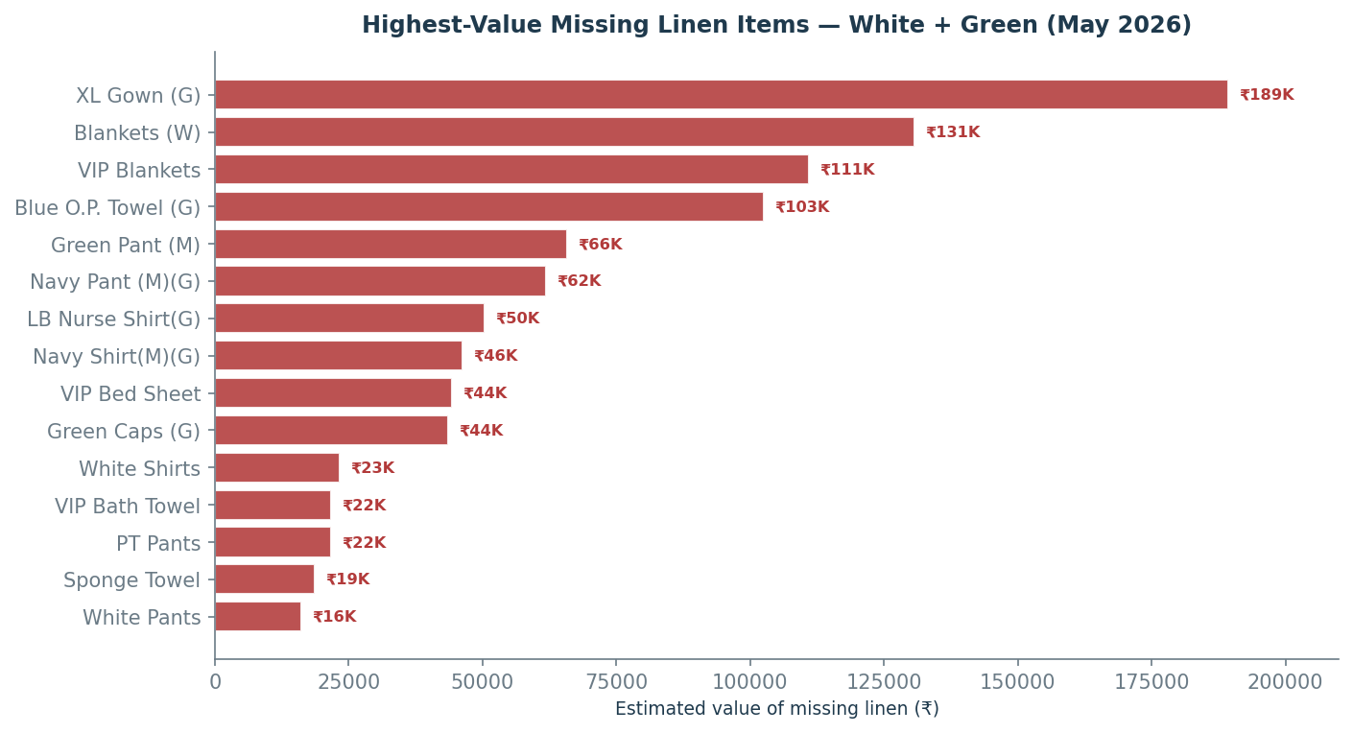
Figure 16: Highest-value missing-linen items across both streams (May 2026)
Stream | Total Units Missing | Estimated Value (₹) | Largest Single Loss
White (incl. VIP) | 1,094 | ₹ 4,37,249 | Blankets - ₹1,30,680
Green / OT | 3,062 | ₹ 6,54,352 | XL Gown - ₹1,89,225
Combined (May) | 4,156 | ₹ 10,91,601 | -
Table 12: Missing-linen value summary. Against the literature’s 2-5% acceptable annual loss benchmark, a single-month gap of this scale at one site is materially above norm

- Procurement Quantity Plan

Diagnosis must lead to a concrete buying decision. For every item the shortfall to 3-PAR (3-PAR minus observed) plus a 10% buffer gives the exact quantity to procure no more, no less. This converts the analysis directly into a costed indent. For the White stream the priority buys are bath towels (130 with buffer), PT pants (162), PT shirts (115) and sponge towels (242); for the Green/OT stream the urgent buys are green bed sheets (427), blue O.P. towels (299), green O.P. towels (251) and green/navy garment sizes running short. Critically, items already in excess (white pants, white shirts, surgeon gowns, medium towels) generate a procurement quantity of zero the model actively prevents the over-buying that the PAR assessment showed was previously routine.

Stream | Items needing purchase | Qty to procure (with 10% buffer) | Indicative cost
White / VIP | Bath, PT Pants, PT Shirts, Sponge, VIP Blankets | ≈ 662 units | ≈ ₹ 67,685
Green / OT | Green/Blue towels, bed & draw sheets, garment sizes | ≈ 2,391 units | ≈ ₹ 5,64,647
Table 13: Procurement plan summary: only genuine 3-PAR shortfalls are bought, preventing over-indenting

- Cost-Impact Analysis

The cost-impact analysis separates two distinct financial effects. The annual cost of missing linen (missing quantity × unit cost × 12) estimates the recurring replacement burden if the current loss rate persists: roughly ₹52.5 lakh per year for the White stream and ₹78.5 lakh for the Green/OT stream on a single-site basis. The monthly cost of shortage (shortage quantity × daily issue × unit cost) captures the operational exposure created by items running below 3-PAR. These figures are intended to convey order of magnitude and direction rather than audited values, and their scale alone makes the business case for the system.
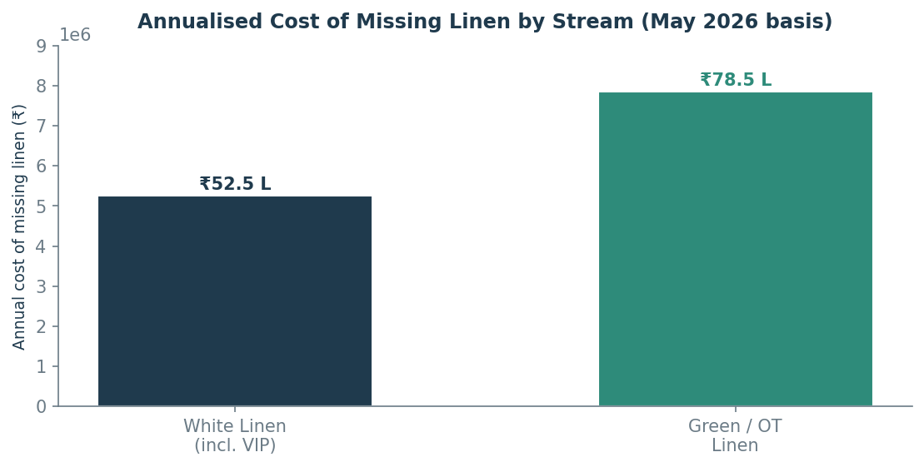
Figure 17: Annualised cost of missing linen by stream (single-site, May 2026 basis)

The strategic reading is simple: because Quick Clean owns the linen under the rental model, every one of these rupees is the operator’s cost, not the hospitals. A single pilot site is leaking lakhs of rupees of linen value a month into an untracked void. Extrapolated across Quick Clean’s healthcare portfolio, the recoverable value is the central economic justification for investing in the tracking system this project proposes.

- Discard and Trend Analysis

Discard data was captured daily across both streams for May and benchmarked against the prior three months. Two questions were asked: which items are being lost to wear fastest, and is the rate of attrition rising or falling? A normal 18-day discard rate for general hospital linen sits in the 2-5% band; rates well above this signal something other than normal wear sub-specification fabric, or exposure to excessive chemical or mechanical stress.
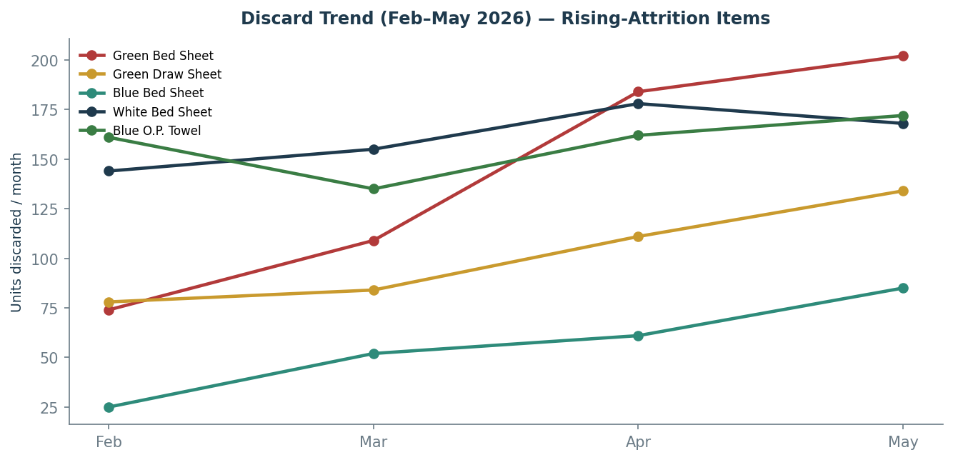
Figure 18: Month-on-month discard trend (Feb–May 2026) for the highest-attrition items

The trend analysis flags a clear and worrying pattern in the green stream: green bed sheets (74 → 109 → 184 → 202), green draw sheets (78 → 84 → 111 → 134) and blue bed sheets (25 → 52 → 61 → 85) are all on a steep rising trajectory, as are blue O.P. towels and several green garment lines. A green bed sheet discard rate of roughly one-third of audited stock in eighteen days, averaging 6.5 pieces a day, is firmly in the “high” category and points to a fabric-quality or wash-process issue that warrants supplier and chemistry review. By contrast, several white items (pillow covers, bath towels, PT shirts) are on a falling trend, indicating those categories are stabilising.

Discard rate band | Interpretation | Example items (May)
High (>5%) | Wearing out fast; review fabric & wash quality | Green/Blue bed & draw sheets, white draw sheets
Moderate (2-5%) | Normal wear; monitor monthly | White bed sheets, white gowns, skin towels
Low (<2%) | Lasting well | White shirts/pants, surgeon & XL gowns, VIP items
Table 14: Discard-rate categorisation and representative items

- PAR-Estimate Accuracy: The Cross-Stream Picture

Aggregating the PAR assessment across both streams sharpens the central message. The April estimates were overwhelmingly wrong, and wrong in both directions a large number of items over-estimated (driving wasteful over-purchase) alongside a meaningful set under-estimated (guaranteeing chronic shortage). No procurement function can plan reliably on such a base.
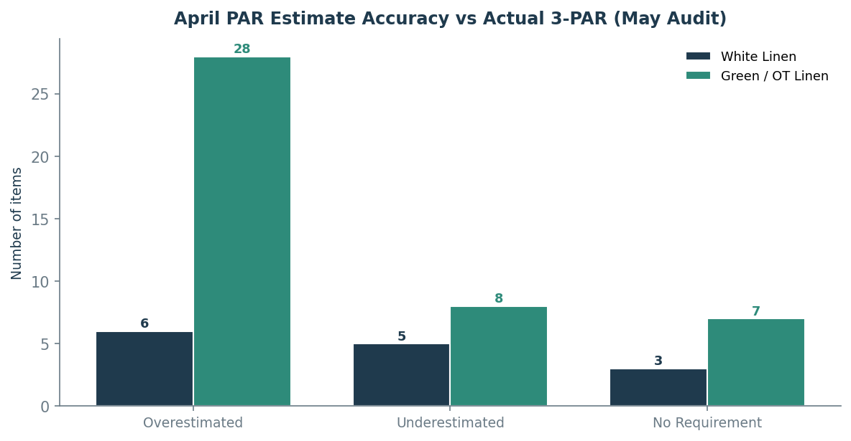
Figure 19: Accuracy of April PAR estimates versus the actual May 3-PAR, by stream

4.4 Synthesis of Findings

- The system is mis-counted, not merely under-stocked. Both streams show excess and shortage co-existing item-by-item the signature of a tracking failure.
- Over ₹10.9 lakh of linen is unaccounted for in a single month at one site, with an annualised missing-linen exposure well into the crores across the portfolio.
- OT linen is the critical risk zone, with core surgical items in deep, conservative shortage and rising discard trends.
- April PAR estimates are unreliable in both directions, causing simultaneous over-buying and stockouts.
- Green bed-sheet and draw-sheet attrition is abnormally high and rising, pointing to a fabric or wash-process problem beyond normal wear.

CHAPTER 5

DESIGNING THE TRACKING & REPORTING SYSTEM

CHAPTER 5: DESIGNING THE TRACKING & REPORTING SYSTEM

5.1 Design Philosophy

The system was deliberately designed around a single principle: every linen item must carry one name and one identity from the moment it is procured to the moment it is condemned, and that single identity must flow through every template, every analysis and every approval. The architecture therefore has three layers that share one data schema. At the data-capture layer sits a standardised Excel toolkit that the linen manager fills at each site. At the workflow layer sits a digital discard-approval platform that governs how linen leaves the system with documented evidence. At the visibility layer sits a centralised dashboard that lets the head office see every site at once. A phased tagging roadmap underpins all three by giving each piece a machine-readable identity over time. The remainder of this chapter describes each component and the value it creates.
Critically, this is not a theoretical design. Each component was built, populated with the Lilavati audit data, and demonstrated to the operations and finance teams during the internship; the head of operations intends to use it as the base for a wider tracking initiative across all healthcare sites.

5.2 Component 1: The Standardised Linen-Management Toolkit

The first and most foundational deliverable is a single Excel workbook the Quick Clean Linen Management Standard Template that replaces the patchwork of inconsistent, site-specific sheets with one master format mandatory across all sites. It is built on a strict input-versus-calculation discipline: the linen manager fills only the designated input cells, and every PAR figure, variance, cost and status flag is computed automatically, removing the manual-calculation errors and wrong-column entries that Chapter 3 identified. The workbook contains six linked modules.
 | Module | What it does | Gap it closes
1 | SITE INFO | Captures site name, code, bed configuration and the master item list with fixed item codes used by every other sheet. | Mismatched item names
2 | WHITE LINEN PAR | Opening stock, purchases, discards, expected closing, ward + laundry counts → auto 1-PAR / 3-PAR, variance and status per item. | No reconciled count; wrong columns
3 | GREEN LINEN PAR | Same logic for OT / CSSD stream, with an added mending column reflecting OT-specific handling. | No reconciled count (OT)
4 | DISCARD LOG | Item, category, stock on audit date, total and daily-average discard, % of stock, auto discard-category (High / Moderate / Low) and months-to-depletion. | Incomplete, un-analysed discard
5 | PROCUREMENT REQUISITION | Standard, same-format indent generated from the 3-PAR shortfall, with LM, RM and HO sign-off fields. | Guesswork procurement
6 | MONTHLY SUMMARY | A one-page site dashboard: items in shortage / excess, total missing value, discard alerts - the figures the centralised dashboard consumes. | No single source of truth
Table 15: The six modules of the standardised linen-management toolkit and the specific gap each one closes
Two design choices deserve emphasis. First, every module carries the size-bifurcation columns (S / M / L / XL and above) that the current templates lack, so that a discard or a shortage is always resolvable to the exact size that must be reordered. Second, because all six modules share the SITE INFO master item list, the same item code aggregates cleanly from the daily floor sheet through to the head-office dashboard -the single-identity principle made concrete. A linen manager who fills only the pink input cells obtains a complete, reconciled, analysis-ready inventory picture without performing a single manual calculation.

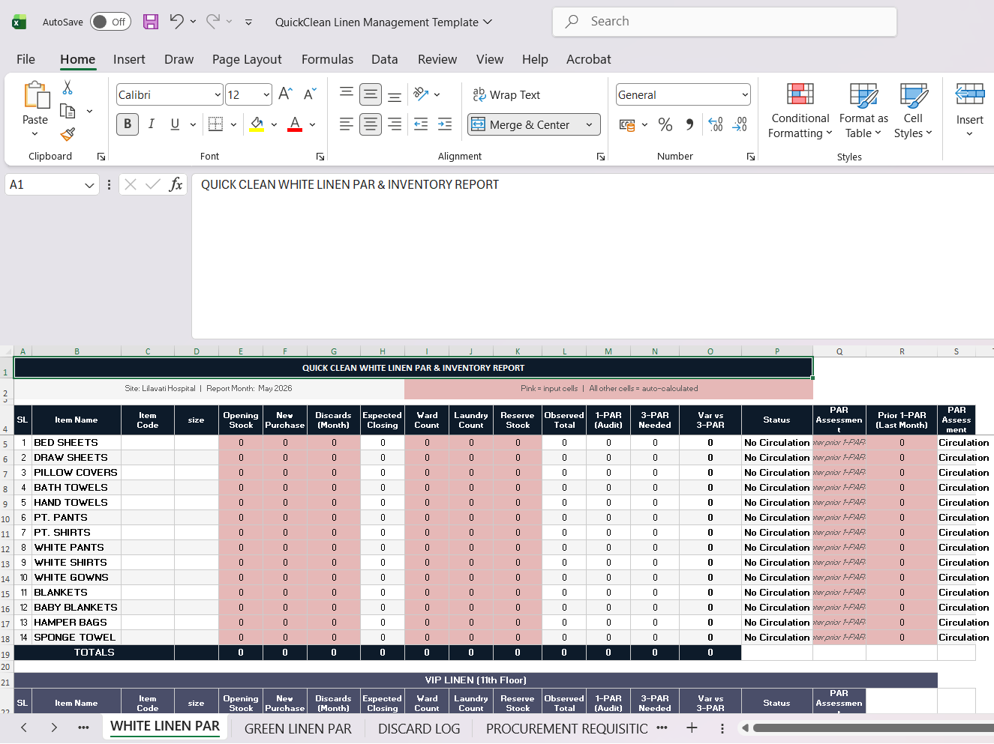
Table 20: The standardized template that is been delivered to quick clean after analysis

5.3 Component 2: The Quick Clean Discard Management Platform

The second deliverable addresses the approval gap directly. Today a discard is a paper event with no evidence trail, which is precisely why the finance team had, on occasion, refused to sanction write-offs. The Quick Clean: Linen Discard Management platform (a web application) converts condemnation from an unverifiable paper claim into an auditable, photo-backed digital transaction that moves through a defined approval chain.
The workflow is simple for the person on the floor and rigorous for the organisation. Site staff raise a discard, mending or conversion request, attaching a photograph of the item and its barcode / tag as evidence. The request then escalates through a multi-level approval chain from the laundry manager, to the regional manager, to the head office with each level able to approve or query. Because every condemnation now carries a photograph, an item identity and an approver trail, the finance team receives ready-made evidence for each write-off, and disputes over unsupported discards disappear.
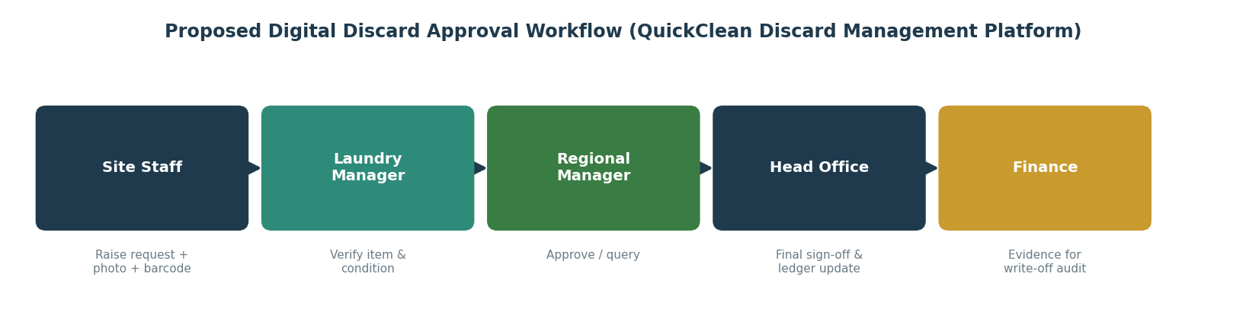
Figure 21: The digital discard-approval workflow implemented in the Quick Clean Discard Management platform -from evidence capture at the floor to finance-ready write-off

How the Platform Works: Architecture

Under the surface, the platform follows a conventional and robust three-tier web architecture. The front end the screens used by floor staff and approvers to raise requests, upload photographs and action approvals communicates with a back-end application layer written in Java, which holds the business logic: who may raise a request, the order of the approval chain, what constitutes valid evidence, and how an approved discard updates the stock ledger. Behind this sits a relational SQL database that stores every request, its photographic evidence reference, the item and site identifiers, the approval status at each level, and a permanent timestamped audit log. The data flow is therefore a clean loop:

capture at the floor, validate in the Java layer, persist in the SQL store, and surface to each approver and ultimately to finance.
The design value of this architecture is traceability. Because the database records the full lifecycle of every discard request, the platform can answer questions the old paper system never could: how many items of a given type were condemned this month, at which site, for what reason, approved by whom, and with what evidence. It is this property a permanent, query able, evidence-linked record that makes the platform genuinely futuristic for the organisation, and that lays the groundwork for using condemnation data to compute average wash-cycle life per item once tagging matures.
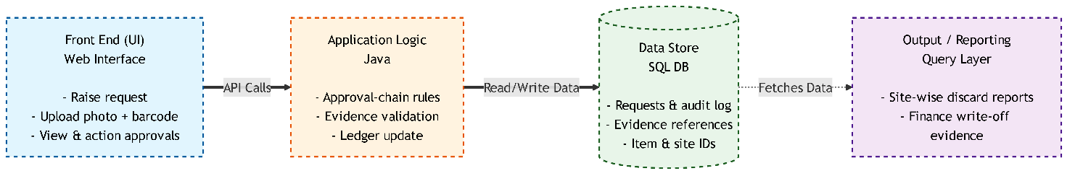
Figure 22: The three-tier architecture of the discard-management platform

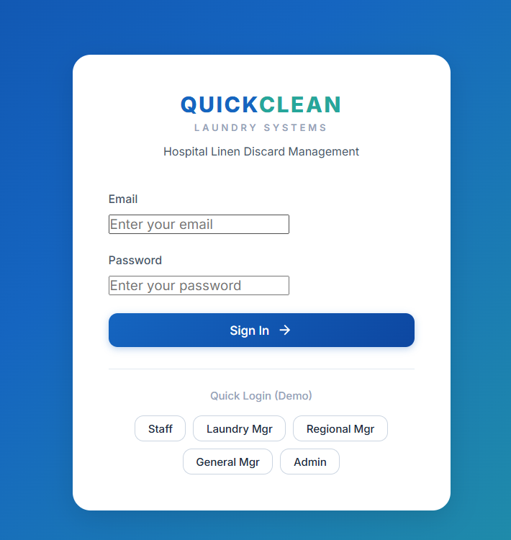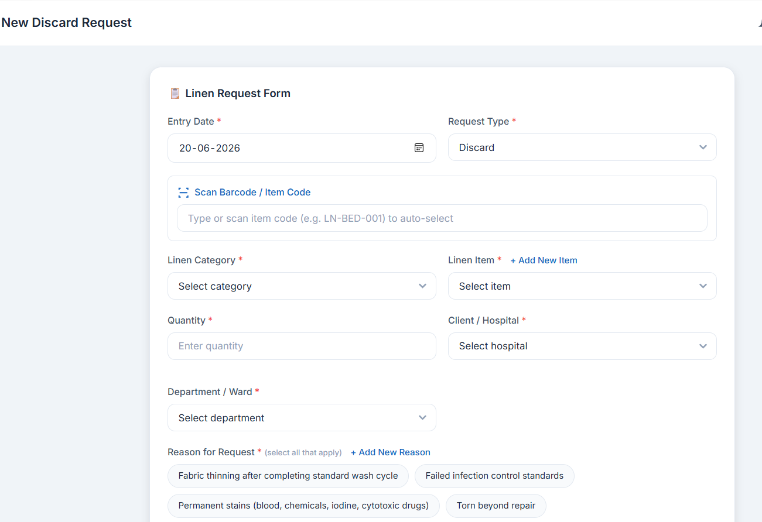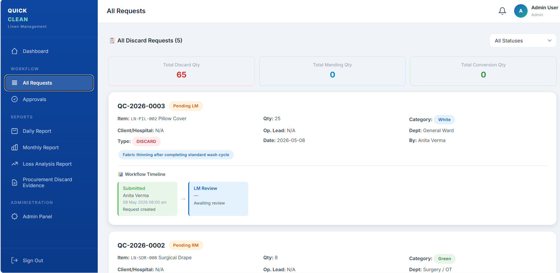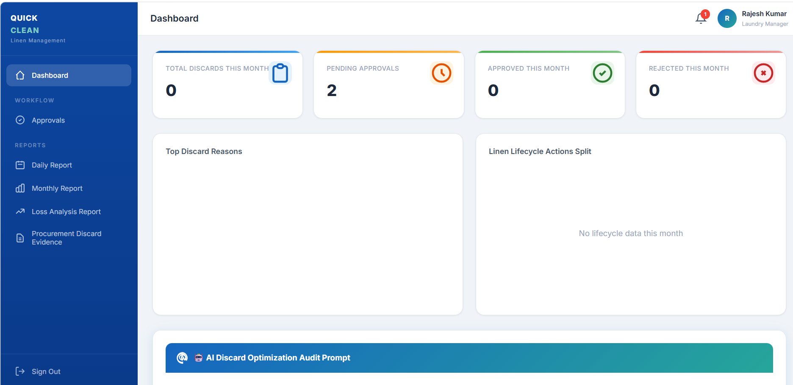
Figure 23: The Quick Clean Discard work flow dashboard which is being delivered

5.4 Component 3: The Centralised Inventory-Tracking Dashboard

The third deliverable lifts the analysis from a single site to the whole portfolio. The standardised toolkit makes each site’s data clean and comparable; the centralised inventory-tracking dashboard a web application built and deployed on the Streamlit framework then aggregates that data so that the head office and regional heads can see every hospital in one place. The operating model is straightforward: each site’s linen manager uploads the monthly toolkit output, and the dashboard instantly renders the PAR position, variance, missing-linen value, procurement need, cost impact and discard trend for that site and, crucially, allows those metrics to be compared across sites.
This converts inventory management from a reactive, site-by-site, end-of-month scramble into a proactive, exception-driven discipline. Instead of waiting for a problem to surface at one hospital, the head office can scan the whole estate at a glance, identify which sites are leaking the most value, which are running below 3-PAR on critical OT items, and which are showing abnormal discard trends, and direct attention precisely where the rupees are. The same Trends view used to present the Lilavati findings in this report becomes, at scale, a live cross-site benchmarking tool.

How the Dashboard Works: Architecture

The dashboard is written in Python using the Streamlit framework, which renders interactive data applications directly from analytical scripts. The data layer reads the standardised toolkit workbooks (the same single-schema item codes used everywhere else); a Python analytical layer using the panda’s library for data manipulation recomputes the eight analyses for each uploaded site and stores the results; and a presentation layer renders them as interactive charts, sortable tables and per-site trend lines that an executive can filter without touching a spreadsheet. Because the analysis logic is identical to that applied to Lilavati, every site is judged on exactly the same basis, which is what makes cross-site comparison legitimate.
The strategic value created is visibility the very quality the literature identifies as the single most critical operational challenge in multi-site rental operations. A head-office user can now see, on one screen, which of Quick Clean’s healthcare sites need procurement attention, which are managing linen most efficiently, and where the next rupee of avoidable loss is accumulating.

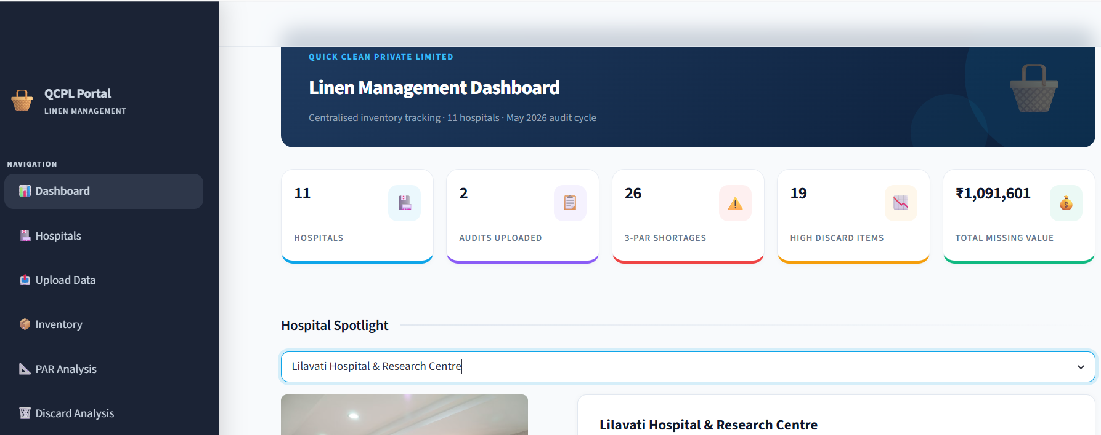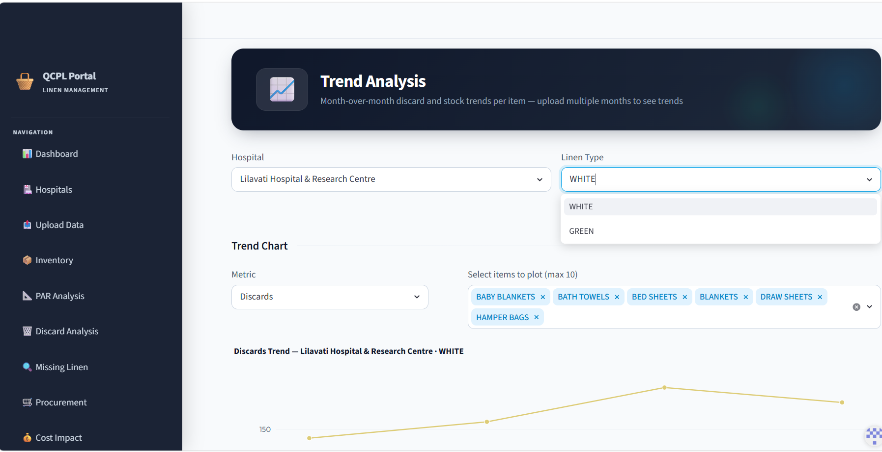
Figure 24: The QCPL-Centralised Inventory-Tracking Dashboard which is being delivered

5.5 Component 4: A Phased Linen-Tagging Roadmap

Each of the three components above is strengthened immeasurably once linen carries a machine-readable identity. The literature’s strongest single finding that item-level tracking can cut linen loss from around 15% to as little as 3% points squarely at tagging. Full RFID, however, is a heavy capital commitment that cannot be justified at every site on day one. The recommendation is therefore a deliberately phased roadmap that delivers value at each step and earns the case for the next.

Phase | Mechanism | What it enables | Investment
Phase 1 (Now) | Stamping / indelible marking with department, month & year | Basic ownership, age of piece, contractual tagging compliance restored | Minimal
Phase 2 (3–6 months) | Barcode tag: item code + size + department + month/year + serial | Per-item scanning on issue, return & discard; wash-cycle counting; size-accurate discard | Moderate
Phase 3 (6 months +) | RFID tags (survive 200+ washes) | Full lifecycle traceability, automated counts, auto-retirement at cycle limit, real-time PAR | Higher justified by Phase-2 savings
Table 16: The phased linen-tagging roadmap: stamping, then barcode, then RFID- each phase funding the case for the next

The sequencing matters as much as the technology. Phase 1 restores contractual compliance immediately at negligible cost. Phase 2 a barcode encoding item code, size, department and month/year is the pivotal step: it makes every issue, return and discard a scannable event, enabling the average wash-cycle and discard analyses the company wants and finally making loss measurable at the piece level. Phase 3 (RFID) then automates what Phase 2 made possible, and its substantial cost is underwritten by the losses Phase 2 will already have demonstrated and begun to recover.

5.6 How the Four Components Work Together

The power of the system lies in the connections, not the parts. The toolkit standardises and cleans the data at source; tagging gives each piece the identity that makes that data trustworthy; the discard platform governs the single most error-prone outflow with auditable evidence; and the dashboard turns the cleaned, trusted, governed data into portfolio-wide visibility and decisions. Each component closes specific gaps from Chapter 3, and together they convert linen inventory at QuickClean from an untracked grey area into a measured, managed and continuously improvable system which was the whole purpose of the project.

CHAPTER 6

RECOMMENDATIONS

CHAPTER 6: RECOMMENDATIONS

The recommendations below follow directly from the audited evidence and the system design. They are organised on a deliberate time horizon immediate, short-term and long-term so that the organisation can begin recovering value within weeks while building towards full lifecycle traceability. Each recommendation is tied to a gap quantified earlier in this report, and the chapter closes with the international best practices and the KPI framework against which progress should be measured.

6.1 A Phased Recommendation Roadmap

The single most important message is that the company need not wait for technology to begin recovering value. The largest and quickest gains come from disciplines that cost almost nothing: standardising item names, adding size bifurcation, and reconciling stock monthly. Technology then amplifies these gains rather than substituting for them.
Horizon | Recommended Action | Gap / Finding it addresses
IMMEDIATE (0-1 month) | Adopt the single master item list and fixed item codes across every template; eliminate name mismatches. | Mismatched names
IMMEDIATE | Add size bifurcation (S/M/L/XL+) to floor-issue, inventory and discard templates. | No size split; OT garment shortages
IMMEDIATE | Begin daily closing-stock entry capturing ward, laundry and fresh stock separately. | No reconciled count
IMMEDIATE | Enforce the full SOP discard criteria torn, thinning and stained not torn alone. | Incomplete discard
IMMEDIATE | Action the costed procurement plan to lift the deep OT shortages (green bed sheets, blue O.P. towels) toward 3-PAR. | OT shortage
SHORT-TERM (1-6 months) | Roll out barcode tagging (item + size + department + month/year) to enable scan-on-issue, return and discard. | Tagging; Phase 2
SHORT-TERM | Operationalise the digital discard-approval platform across sites so every write-off carries photo evidence. | Finance disputes
SHORT-TERM | Standardise the 3-PAR calculation site-wise and refresh it monthly from actual floor-issue data. | Unreliable PAR estimates
SHORT-TERM | Investigate the rising green-linen discard trend with the supplier and wash-chemistry team. | Abnormal attrition
LONG-TERM (6 months +) | Introduce RFID tagging for full lifecycle traceability and automated wash-cycle retirement. | Phase 3
LONG-TERM | Scale the centralised dashboard into a live cross-site benchmarking and predictive-procurement tool (auto-flag below 2-PAR). | Portfolio visibility
LONG-TERM | Pursue alignment with HLAC / TRSA-style documented quality standards as a differentiator. | Accreditation
Table 17: The phased recommendation roadmap, each action mapped to the specific gap or finding it resolves

6.2 International Best Practices Worth Adopting

Healthcare-linen operators in more mature markets have converged on a set of practices that Quick Clean can selectively adopt to leapfrog its current state. Four are most directly relevant.
- Item-level RFID and the loss-recovery case. International operators report that automated item-level tracking cuts linen loss from the 15-25% range typical of untracked facilities to as little as 3%, with documented single-year savings running into hundreds of thousands of dollars at a single large facility. Given that this project found over ₹10.9 lakh of unaccounted linen in one month at one site, even a partial loss reduction of this order represents a compelling return on the phased tagging investment.
- Independent hygiene accreditation (HLAC / TRSA Hygienically Clean). In North America, healthcare laundries are accredited against inspected standards and microbiological testing valid for three years. Pursuing comparable documented standards would give Quick Clean an external, auditable quality credential that differentiates it commercially and pre-empts client concerns over infection control.
- Ward-level stock caps and segregation discipline. Best-practice SOPs (e.g. the Sydney Children’s Hospitals Network) cap ward storage at roughly one day’s supply, mandate strict clean/soiled separation in transport, and require torn or stained clean linen to be returned for re-crediting. Adopting ward-level caps would directly counter the over-stocking that quietly inflates apparent demand and hides losses.
- PAR levels set on real usage data, not estimates. Mature operators reset PAR continuously from scanned usage data rather than annual estimates. Once barcoding is live, Quick Clean should retire the static annual PAR estimate shown in report is to be unreliable in both directions in favour of a rolling, data-driven PAR refreshed monthly.
National compliance anchors this international view: NABH (6th Edition) and the NHSRC mechanised-laundry and CSSD guidelines already require segregation at source and disciplined discard into marked bags. The recommendations above are therefore not merely aspirational imports several are domestic compliance obligations that the proposed system helps Quick Clean meet.

6.3 A KPI Framework for Ongoing Control

To ensure the system delivers sustained value rather than a one-off clean-up, the company should track a small, disciplined set of key performance indicators every month, site by site, through the centralised dashboard. These KPIs translate the literature’s standard linen-operation metrics into Quick Clean’s context.
KPI | Definition | Target / Benchmark
Linen loss rate | Missing units ÷ total stock, per month | ≤ 2-5% per annum (industry band)
Inventory variance | Book (expected) vs physical (observed), item-wise | Trending towards zero; no co-existing excess + shortage
3-PAR fulfilment | % of items at or above 3-PAR target | 100% for critical OT and ward items
Discard rate by item | Daily discard ÷ stock, categorised High/Mod/Low | No item sustained in “High” band
Pending discard approvals | Count of unactioned requests in the platform | Near zero-no approval backlog
Procurement accuracy | Indented qty vs genuine 3-PAR shortfall | No over-indent on excess items
Tagging coverage | % of pieces carrying a scannable identity | Rising each phase towards 100%
Table 18: Recommended monthly KPI framework, tracked site-wise through the centralised dashboard

Read together, these KPIs give the head of operations exactly what was missing at the start of the project: a single, trusted, repeatable scorecard that shows, for every site, whether linen is under control and where the next rupee of avoidable loss lies.

CHAPTER 7

CONCLUSION, LEARNINGS & SCOPE FOR FUTURE WORK

CHAPTER 7: CONCLUSION, LEARNINGS & SCOPE FOR FUTURE WORK

7.1 Conclusion

This project set out to develop an operational understanding of how healthcare linen inventory is managed under Quick Clean’s rental model, and to convert that understanding into a workable system. Beginning from what the Head of Operations frankly called a “grey area”, the work produced, for the first time, a defensible, evidence-based picture of linen inventory at a real site. A full physical audit of Lilavati Hospital on 18 May 2026 reconciling ward circulation, laundry and fresh stock against the book figure revealed that the system is not merely under-stocked but mis-counted: across both linen streams, excess and shortage co-exist item by item, the unmistakable signature of a tracking failure rather than a simple buying error.
The scale of the gap is material. In a single month at a single site, over ₹10.9 lakh of linen was unaccounted for, OT linen sat in deep and conservative shortage on its most critical items, April’s PAR estimates proved unreliable in both directions, and green-linen attrition was both abnormally high and rising. Because Quick Clean owns the linen under the rental model, every rupee of this is the operator’s own cost which is precisely what makes the business case for the system so strong.
Against this diagnosis, the project delivered a connected, four-part solution: a standardised six-module Excel toolkit that cleans and reconciles data at source; a digital, evidence-backed discard-approval platform that ends finance disputes; a centralised dashboard that gives the head office portfolio-wide visibility; and a phased tagging roadmap that moves the organisation from stamping to barcoding to RFID as the savings compound. Each component closes a specific, named gap, and together they answer all three objectives of the study. Most importantly, the framework built at Lilavati is designed to be applied unchanged at every Quick Clean healthcare site, turning a one-site audit into an organisation-wide capability.

7.2 Key Learnings from the Internship

- Data discipline beats data volume. The single most damaging problem was not a lack of records but inconsistent one’s mismatched names and missing size detail quietly corrupted every downstream number. A small amount of standardisation discipline recovers more value than any sophisticated analysis layered on bad data.
- A pilot, chosen well, generalises. Auditing the hardest site rather than the easiest meant the method earned the right to be applied everywhere.
- Evidence changes decisions. Putting a rupee value on missing linen, and a photograph on every discard, shifted the conversation with finance and procurement from opinion to fact a lesson in how operational analysis actually creates influence inside an organisation.
- Cross-functional reality. Working across operations, purchase, finance and site teams showed how an inventory number is only as trustworthy as the weakest hand-off between functions.

7.3 Scope for Future Work

- Extend the audit-and-analysis cycle to all Quick Clean healthcare sites and populate the centralised dashboard with the full portfolio, enabling genuine cross-site benchmarking.
- Complete the barcode roll-out and, after a few months of scan data, replace static PAR estimates with rolling, usage-driven PAR levels and begin measuring true average wash-cycle life per item.
- Use the accumulating discard-platform data to build a predictive procurement model that auto-flags reorder when an item approaches 2-PAR.
- Conduct a dedicated fabric-quality and wash-chemistry investigation into the rising green-linen discard trend, jointly with the supplier.
- Develop the business case for RFID at the highest-value sites, underwritten by the loss-recovery evidence the barcode phase will have produced.
- Pursue formal alignment with documented hygiene-accreditation standards as a commercial differentiator.
In closing, this project demonstrates that the path from an untracked grey area to a measured, managed inventory system does not require waiting for expensive technology it begins with the discipline of one item, one name, one identity, counted honestly and reconciled every month, with technology brought in to amplify that discipline as the recovered value pays for it.

BIBLIOGRAPHY & REFERENCES

BIBLIOGRAPHY & REFERENCES

The following academic studies, institutional standards and industry sources informed the literature review, methodology and recommendations of this report. Web sources were last accessed in June 2026.

Academic & Peer-Reviewed Studies
- Gajuryal, S. (2023). A Study on Hospital Linen and Laundry Management Services. B.P. Koirala Institute of Health Sciences (BPKIHS), Nepal.
- Merlin, & Ruth Mary. (2024). A Study on Inventory Management of Linen in the Outpatient Department of a Tertiary Care Hospital. International Journal for Multidisciplinary Research (IJFMR), Vol. 6.
- Sarla, G. S. (2023). Hospital Laundry and its Environmental Implications. Journal of Hospital Administration & Environmental Health.
- Desai, P. (n.d.). Management of Supportive Services in Hospitals: Linen and Laundry. Hospital Administration Reference Series.

Standards, Guidelines & Institutional SOPs
- National Accreditation Board for Hospitals & Healthcare Providers (NABH). (2025). Accreditation Standards for Hospitals, 6th Edition. Quality Council of India.
- National Health Systems Resource Centre (NHSRC). Guidelines for CSSD and Mechanised Laundry in Public Health Facilities. Ministry of Health & Family Welfare, Government of India.
- Sydney Children’s Hospitals Network (SCHN). (2024). Linen Management Procedure. Government of New South Wales, Australia.
- Federal Ministry of Health, Ethiopia. Infection Prevention and Patient Safety – Chapter 8: Linen and Laundry Management.
- Standards Australia / Standards New Zealand. AS/NZS 4146: Laundry Practice.
- Centers for Disease Control and Prevention (CDC). Guidelines for Environmental Infection Control in Health-Care Facilities – Laundry and Bedding.

Industry, Accreditation & Technology Sources
- Healthcare Laundry Accreditation Council (HLAC). (2024). Accreditation Standards for Processing Reusable Textiles for Use in Healthcare Facilities.
- TRSA. Hygienically Clean Healthcare Certification - Programme Standard and Microbial Testing Protocol.
- Dataintelo. (2026). RFID Linen Tracking Systems for Healthcare -Market Analysis Report.
- RFID Tag. (2026). RFID in Hospital Linen Management: Loss Reduction Case Studies.
- Quick Smart Wash. (2026). RFID-Based Linen Utilisation and Cost Recovery in Commercial Laundries.
- CORE Linen Services. (2026). Where Hospital Linen Really Goes: Understanding Linen Loss.

Primary & Company Sources

- Quick Clean Private Limited. (2026). Lilavati Hospital Linen Inventory Records, Bed-wise Requirement Sheets, CSSD/OT Requirement Lists and Discard Logs (April-May 2026).
- Primary physical stock audit conducted by the author at Lilavati Hospital & Research Centre, Mumbai, 18 May 2026.
- Author’s field observation notes and stakeholder interactions (Operations, Purchase, Finance and site linen teams), April-June 2026.

THANK YOU

